Chapter 3. Collective excitations and quasi-particles in solids
Contents

3.1. Different movements processes in solids
3.2. Quasi-particles statistics
3.3. Photons
3.4. Phonons
3.5. Magnons
3.6. Electrons in atoms and in crystals
3.7. Summary

3.1. Different movements processes in solids

A solid is characterized by the elasticity, strength and hardness, that seemingly excludes the possibility of any internal movement. However, in crystals, there are different types of particles motion and displacement.
Firstly, in crystals a movement of defects is possible – interstitial atoms, dislocations and vacancies (see Section 1.5). In the vicinities of defects the energy of crystal is increased, so defects can move very slowly in order to find an energetically more favourable configuration.
Secondly, another type of atoms or ions in solids movement is a diffusion. Its mechanism is a result of thermal fluctuations: kinetic energy of some particles may grow large enough to exceed a potential barrier that separates one particle from another in different positions of a crystal, and then break neighbouring particle equilibrium. In most crystals, the probability of such a process at temperature near 300 K is small, but it increases significantly, while approaching to the melting point of a crystal. According to this, the diffusion may be classical example of atoms motion in the solids.
Thirdly, in solids, some of electrons can move, and just their movement determines electrical and magnetic properties of a matter. Compared with the velocity of electrons in solids, the velocity of atoms or ions is very small, so during investigation of ionic (or atomic) processes they can be considered as immobile (adiabatic approximation). An accuracy of this approximation is determined by the parameter (т/М)^{1/2} – a ratio of the electron’s mass m to the mass of the ion M.
However, a possibility of movements in solids is not limited by these three mechanisms. To explain solids characteristics, it should be imagined, that there are some other ("hidden") states, which resemble properties of various aggregate states of matter, namely a gas of quasi-particles (constrained electrons, vibrations of atoms in the lattice), a quantum fluid (electrons in the metal) and even an electron-hole plasma (in semiconductors at certain conditions).
Quantum mechanics describes microscopic objects only mathematically, and, certainly, any classical model of quasi-particle is not adequate. However, quantum (wave) mechanics allows to keep an idea of quasi-particles as some "clusters" in crystals; they might be described by overall picture of waves, that looks like "wave-clots" or “wave-packets”, Fig. 3.1.

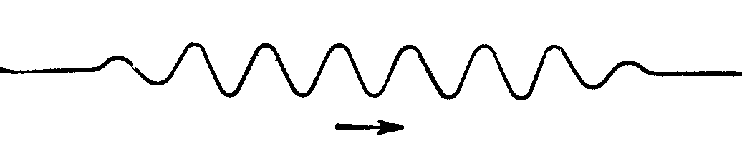
a
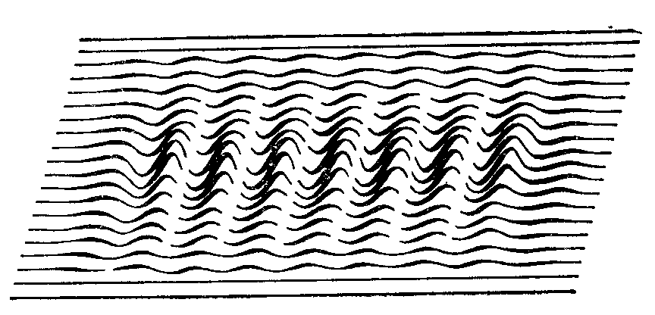
b
Fig. 3.1. Wave packet: a – one-dimensional representation; b – two-dimensional representation

For example, a free movement of electrons in a crystal can be imagined as spreading wave packet, Fig. 3.1, b. Proper electron might be located in any point of a wave packet, but probability to find electron in a definite point is close to zero. Shown in Fig. 3.1 wave amplitude describes only a probability to find the particle at some point; more precisely: this probability is proportional to the square of amplitude of a wave. Such is possible understanding of a wave, which accompanies moving quasi-particle.
Thus, the quasi-particle is a collective motions of many particles of solids, such as local vibrations of atomic group in the crystal lattice. Although each oscillation involves many atoms, this movement nonetheless has an atomic scale, as the average energy of each oscillation (phonons) is about k_{В}Т.
Another example of collective motion is the electronic excitation of atoms or molecules, which, for example, arises when lattice absorbs a photon. This collective excitation is not localized in a particular cell of the crystal, but moves from cell to cell in the form of an exciton. The average energy of an exciton has the same order of magnitude, as the energy of excited state of individual atoms.
There are some phenomena in solids, which involve a lot of quasi-particles. in The event that magnetic moment of ferromagnetic, a model of magnons is used, under the assumption that magnon is a quantum fluctuation of electronic spins. A transfer of electrical charge is described mostly by the electrons (in dielectrics – by polarons), while a heat transfer is indebted to phonons, electrons and magnons.
According classical laws, an average energy of thermal motion of the particles is k_{В}T, and, therefore, an internal heat of solid is Е ~ Nk_{В}T, where N is a number of particles. However, with decreasing temperature, a simple linear dependence of energy on temperature E(T) is violated, since the internal energy of solids tends to zero much faster, than linearly (Section 2.7). This fact can be explained by the discrete (quantum) nature of an energy spectrum of solids. That is why, with decreasing temperature, a part of collective excitations of atoms (or ions) freezes out. This process is started below the Debye temperature; usually it equals 100...300 K, however, in some crystals the nonlinearity in Е(Т) dependence is observed at higher temperatures. The greater is the difference between the energy levels, the higher is the temperature of freezing out of appropriate motion. Therefore, the quantum motion in solids may occur at different temperatures. Except of electrons, phonons, excitons and magnons, the quanta of electromagnetic field – photons – can be excited and spread in solid dielectrics an some of semiconductors.

Summarizing, it should be concluded:
• Materials consist of three kinds of elementary particles: electrons, protons, and neutrons. Quasi-particles represent a convenient model of solids, which need to explain the majority of properties of crystals; quasi-particles can exist only inside the solid.
• Movement in a solid might be very complicated; at that, more simple are classical motion in solids: transference of defects, diffusion of atoms and ions, and movement of electrons. However, only these cases are insufficient to account for manifold electrical and thermal properties, so the more complicated collective movements should be considered. Just this is motivation for concept of quasi-particles and collective excitations. By that, a complicated motion of actual particles in a solid can be mathematically transformed into a simpler motion of imagined quasi-particles, which behave more like non-interacting particles.
• Strictly saying, an elementary excitation might be called as a "quasi-particle", if it is a fermion, and as a "collective excitation" if it is a boson. However, in future discussions, both of them are joined under the notion of quasi-particles (with any precise distinction). For example, free electron is a particle, but in the crystal it behaves as if it has different “effective mass”, because it is affected by environment; in both cases electron is a fermion. Another example is a phonon, which characterizes vibrational motion of some atoms in a crystal; it is the collective excitation in a lattice, but it has no “rest mass”, being a boson.
• Quasi-particles are mathematical tool for simplifying the description of some properties of solids. Instead of inconceivable difficult account “how large number of electrons and atoms moves in a specific coordinated way”, a simplified concept of quasi-particles is used.
• In most of solids, the elementary excitations (quasi-particles) are treated as free (independent), but really they are only very close to be independent. That is why, in many cases, it is possible to take into account their interaction, for example, to explain electrons scattering on phonons (electrical resistivity) or phonons-on-phonons scattering (thermal resistivity).
• Using a concept of “quasi-particles / collective excitations”, it is possible, instead of analyzing very large amount of particles (~10²³ cm^{–3} in solids), to deal only with a handful of somewhat-independent elementary excitations. Therefore, this is a very effective approach to simplify the many-body problem in quantum mechanics.

• Electron in solids is a quasi-particle, because it is affected by the forces and interactions. The quasi-particle electron has the same charge and the same spin as the elementary-particle electron, and both of them are fermions. However, in a crystal, the mass of quasi-particle electron can differ substantially from that of a normal electron: it has an effective mass, which might be anisotropic.
• Hole is a quasi-particle, consisting of the lack of electron in a crystal’s cell; a hole has an opposite sign of charge to electron, and the hole also has effective mass, and belongs to the fermions. This concept is commonly used in the context of empty states in the valence band of a semiconductor.
• Exciton is an electron and a hole bound together.
• Polaron is quasi-particle, which comes about when electron interacts with surrounding ions through their polarization; polaron has an increased effective mass and belongs to fermions.
• Phonon is a collective excitation, associated with the collective vibration of atoms (or ions) in a rigid crystalline structure. Phonon might be a quantum of the sound wave, its rest mass is zero, and it belongs to bosons.
• Magnon is a collective excitation, associated with electronic spin structure in a crystal lattice. It is a quantum of a spin wave, its rest mass is zero, and it belongs to bosons.
• Photon inside a crystal is the quasi-particle, because it is dependent on interactions with a material. In particular, the “photon-quasi-particle” has a modified relation between energy and impulse (dispersion relation), that is described by the material's index of refraction.
• Polariton is a special form of photon in a crystal, especially seen near its resonance with lattice vibrational mode in a crystal. For example, excited polariton is the superposition of exciton and photon; while phonon-polariton is a superposition of phonon and photon.
• Plasmon is the collective excitation, which is quantum of plasma oscillations (wherein electrons simultaneously oscillate with respect to ionic lattice).

3.2. Features of quasi-particles statistics
The fundamental law of statistical physics is a Gibbs distribution, which determines the probability of microscopic state of a system, that consists of large number of particles with specific values of position and momentum. If a large number of non-interacting particles are moving, according to the laws of classical mechanics, a statistical method of physical system describing is the Maxwell-Boltzmann statistic.
In the quantum systems statistics, the energy distributions of fermions and bosons have different appearance and properties. In the event that particles, whose number in any state is unlimited, the special case of statistics – a Bose–Einstein distribution is used (respectively, such particles are called as bosons). If the particles are subjected to Pauli principle (which proclaim, that only one particle can exist in a certain state), this case corresponds to a Fermi-Dirac distribution, and particles are called fermions. Macroscopic systems, that at a given temperature are found in the thermodynamic equilibrium, have energy and other parameters that almost coincide with their average condition. At high temperatures, when a probability to find the particle in any state is much smaller, than one (number of energy states is much more than particles), as Fermi-Dirac distribution so Bose-Einstein distribution turns into the classic Boltzmann distribution.

Maxwell-Boltzmann distribution, that determines a probability n_{k} of fact, that the particle is found in a state with the energy Е_{k} at temperature T, is given by the formula:
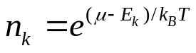,
where μ is chemical potential, T is temperature, k_{B} is Boltzmann constant, showing the relationship of temperature to energy, and equals to the ratio of universal gas constant R to Avogadro number N_{A}: k_{В} = R/N_{A} = 1.38⋅10^{–23} J/K.
Chemical potential is a free energy, that falls to one particle at the state of thermodynamic equilibrium with environment. In turn, free energy is part of total energy, by which system exchange with the environment. Statistical thermodynamics determines chemical potential by the formula μ = (Е – TS + PdV)/N, where E is a total energy of system, P is pressure, V is volume, S is entropy, and N is number of particles in the system. Boltzmann distribution is valid only in cases where n_{k} << 1. This condition can be realized in solids at high temperatures.
In classical statistics, the particle of ideal gas has only kinetic energy. The number of particles, which impulses are found in the interval of (p, p + dp), is determined by the formula:

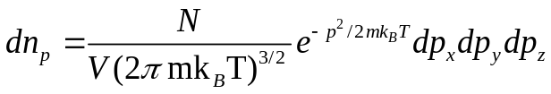 , (3.1)
where m is particle’s mass, V is volume and N is number of particles in the system.

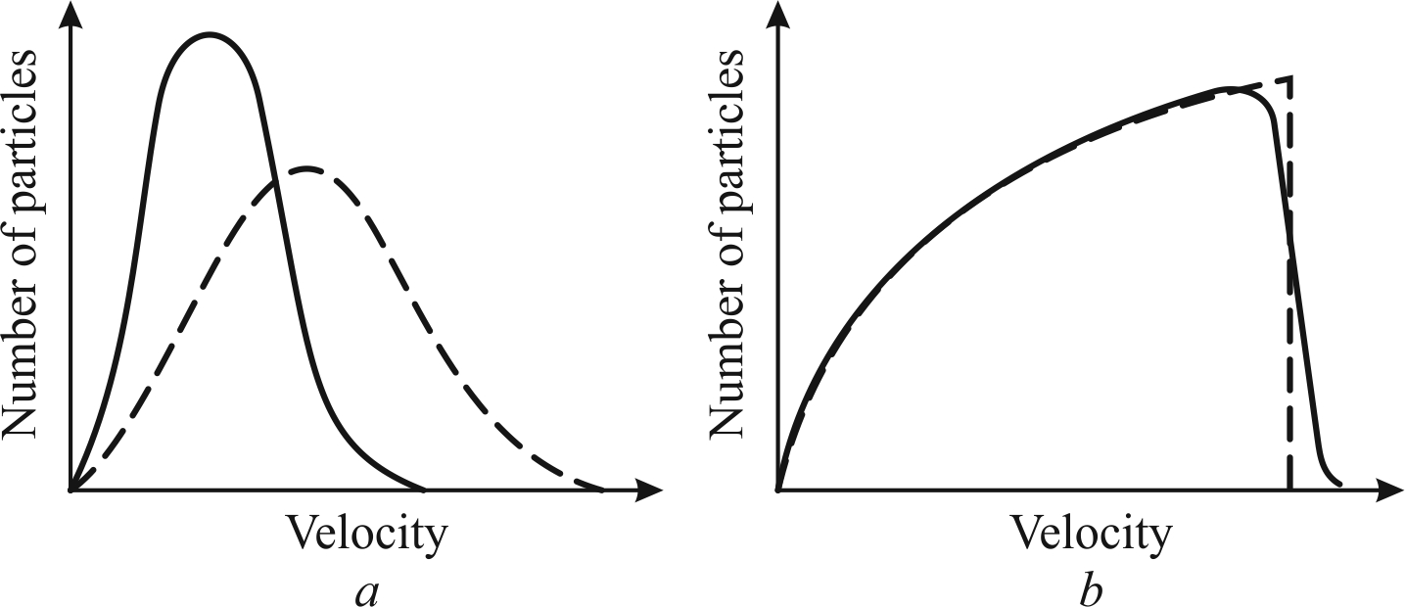

Fig. 3.2. Comparison of classical (a) and quantum (b) distribution of particle by velocities,
a – distribution of gas molecules according to Maxwell-Boltzmann statistics;
b – quantum Fermi-Dirac distribution for the electron gas in the metal

When this formula would be written in terms of the velocities (but not through impulses), it is called as Maxwell distribution:

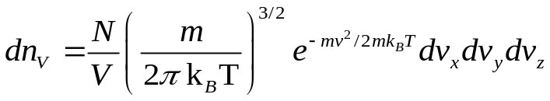. (3.2)

Figure 3.2, a shows a distribution in particles velocities according to Maxwell-Boltzmann statistics; the dotted curve corresponds to a higher temperature.
In the case, where charged particles are ideal gas in an external force field gradient with potential U(r), their free energy changes. In this case, a Boltzmann distribution is dependent on coordinates r and density n₀ of particles:

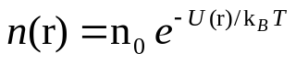. (3.3)
The formulas, similar to (3.3), are valid for density of charge carriers (electrons or holes) distribution in the electrical field in the semiconductors. If free energy has both kinetic and potential energy components, in the Maxwell-Boltzmann distribution instead of μ a total (or electrochemical) potential is introduced: μ – U(r).

Quantum statistics explores systems, consisting of a large number of particles that obey the laws of quantum mechanics. The main task of quantum statistics is to find a distribution function of system of particles by various parameters – coordinates, momentums, energy and so on, as well as to provide calculations of average values of parameters characterizing the macroscopic state of a whole system of particles. This system is called as degenerate, if its properties are very different from classical systems. The behaviour as Bose gas of quasi-particles, so the quasi-particles of Fermi gas differs from that of classical gas, because they are degenerate gases.
The degeneration of quasi-particles gas is significant, when the temperature is very low (phonons) as well as in the event that high densities (electrons in metals). A temperature of degeneracy is parameter T_{d}, below which the quantum properties manifest themselves. If Т >> Т_{d}, the behaviour of particles is described classically.
Quantum statistics is based on the principle of identity or the principle of indistinguishability of micro-particles: all same particles (for example, all electrons in the metal) are not fundamentally different from each other. For fermions, a Pauli principle should be applied: in each quantum state, the only one piece can exists. A full statistical distribution function N(E)dE is introduced, reflecting the number of particles with energies in the interval from E to E + dE. This function is served as the product of number of states g(E)dE, that are attributable to the energy interval dE with distribution function f(E):

N(E)dE = f(E) g(E)dE. (3.4)

A distribution function f(E) determines the probability of filling particles states, attributable to the energy interval dE, i.e., an average number of particles, which are in this state:
f(E) = <N(E)>.

To find full distribution function, functions g(E)dE and f(E) should be calculated. Depending on the symmetry of the wave function, all elementary particles are divided into two classes:
• particles with half-integral spin – fermions;
• particles with integer spin – bosons.
Fermions and bosons show differing behaviour towards microstates: in every cell (in each quantum state) can not be more than one fermion with the set of quantum numbers, or two particles with the anti-parallel spins, but the number of bosons with same parameters may be arbitrary.

Fermi-Dirac statistics for an ideal gas of fermions (Fermi gas) as described with energy distribution function:

f(E) = {exp [(E – μ)/k_{B}T] + 1}^{–1} (3.5)

This expression is called a distribution function of Fermi-Dirac. Chemical potential μ determines the change in system internal energy, when one particle is added, with a condition, that all other values which affect the internal energy are fixed. According to the function (3.5), a probability, that the particle is in a state of energy E = μ, equals to ½. Since the probability must be positive, the value of chemical potential always is less, than the energy of ground state of quasi-particles.
In their main state, fermions occupy the lowest possible energy level. Imposition of the Pauli principle results in the fact, that at zero temperature, when a ground state is realized, all the lowest level of fermions is busy. At that, the highest occupied level in this state is called as Fermi level, and a distribution function has the form of a step, Fig. 3.1, b. In the event of temperature increase, a probability appears, that some fermions of the system will have energy, greater than the energy of the Fermi level. That is why, there is a nonzero probability, that Fermi energy level will be free.
Bose-Einstein statistics describes an ideal gas of bosons (Bose gas of quasi-particles). Quantum particles-bosons differ from the particles of classical physics, because they cannot be distinguished (the principle of particles invisibility). In addition, wave function of bosons always is symmetrical as to particles permutations. Energy distribution of bosons follows from a Gibbs canonical distribution (with variable number of particles), presuming that the number of identical bosons in a given quantum state can be arbitrary:

<N(E)> = f(E) = {exp [(E – μ)/k_{B}T] – 1}^{–1}. (3.6)

This function is called a Bose-Einstein distribution, which determines the probability that a quantum-mechanical many-boson system exists in the single quantum state.
Usage of Bose-Einstein statistics allows to explain temperature dependence of specific heat of solids at low temperatures (see Section 2.7, Debye temperature).
One consequence of quantum Bose-Einstein statistics is an ability to exist in the three-dimensional system at low temperatures in a special phase of matter, consisting of bosons – the Bose condensate.
A value of the chemical potential μ can be found in a condition, that the sum 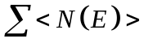<N(E)> is total number of particles in a system:
= N
If the exp[(E – μ)/k_{B}T] >> 1, then as Bose-Einstein distribution so Fermi-Dirac distribution come to classic Maxwell-Boltzmann distribution:

<N(E)> = А exp (–E/k_{B}T), (3.7)

where А = exp (μ/k_{B}T). Thus, at high temperature both "quantum" gases of quasi-particles behave as a classical ideal gas.
From bosons statistics, it follows, that bosons tend to a collectivization – to gather (condense) in one state. Just this property of bosons is a basis of quantum light generators (lasers), and it is a cause of such phenomena as superconductivity and superfluidity. The Bose-Einstein statistics enables to explain electromagnetic radiation, when it is found in a thermal equilibrium with a body. Therefore, the application range of these statistics explains blackbody radiation. Quanta of light – photons – are example of Bose particles.

3.3. Photons

Creating theory of an external photoelectric effect, Einstein showed, that light is not only emitted and absorbed by the quanta, but it is a stream of peculiar particles (photons) that extend with a discrete portion of energy hν, where ν is light frequency. Based on ideas of quantum nature of light, Einstein explained not only photoelectric effect, but other phenomena, that cannot be explained in terms of electromagnetic theory of light (waves).
The duality nature of light has been established much earlier, than wave properties of the electron were discovered. The first supposition as to the corpuscular (discrete) structure of light was formulated, because it is consistent with some of experimental facts. However, among physicists, there was a discussion between supporters of the corpuscular theory of light and proponents of the wave theory of light. Finally, using wave theory a rectilinear propagation of light and laws of refraction and reflection were explained. After theory of electromagnetism creation, any doubt about a wave nature of light disappeared.
However, the only possible explanation of “black-body” radiation laws (as well as photoelectric effect), the corpuscular properties of light should be used: it can be considered as photons, the unusual particles with no rest mass. It can be shown that Coulomb's law – a relatively slow decrease of electrical interaction with distance – owes just to a zero rest mass of the photon. It is known, that electrostatic (Coulomb) interaction of charged particles causes large force (as compared, for example, to gravitational interaction).
Consider the interaction between charged particles q₁ and q₂. If the second particle is removed to "infinity", the first particle creates an electrical field, which potential ϕ is proportional q₁/r. If one brings a removed particle to a distance r, then it will act with a force proportional to q₁q₂/r² and directed from q₁, if electrical charges are of the same sign, or to q₂, if the charges have opposite sign. In the theory of electricity a concept of "potential" is introduced. The existence of electrical field (gradient of potential) indicates the fact, that the point, where electrical charge is located, has some peculiarity. To explain fundamental interactions of electrical charges, a term "electrical field" is introduced, in order to avoid an idea about "long-range interaction" (i.e., immediate power effect on a distance), which is not true, because is in contrary to relativistic theory.
A formula of Coulomb force F = q₁q₂/(4πε₀r²) precisely corresponds to the fact, that a light velocity c is the maximal speed, at which any signal can be passed. The shift of one charged particle (for instance, a charge q₂) cannot "immediately" affect the other particles (q₁): this would be in contradiction to fundamental principle of relativity – a limited speed of signal propagation.
Thus, it can be argued, that conception "electromagnetic field" is need, in particular, in order to avoid conflict with a theory of relativity. The notion, that field “is the force, acting on charged particle in certain point in space” corresponds to the electrical field at this point. If one of the charges, which creates a field, is moved, then, right near this charge, field changes and a wave-disturbance is formed, that can reach a second charge only through the time r/c. Thus, the electromagnetic field provides a short-range action, which is observed in nature.
In the classical physics, charged particles interact by the scheme:

particle → electromagnetic field → particle.

Corresponding quantum scheme is as follows:

particle → photon → particle.
That is, the charged particle during its movement creates a photon, which can be absorbed by another particle, which determines strength of particles interaction. It should also taken into account, that a photon, having electromagnetic nature, is electro- and magnetically neutral particle.
It is also interesting to note, that Coulomb's law (which states, that the force of interaction of charges is inversely proportional to the square of a distance between charged particles) is a consequence of the fact, that mass of photon is zero (m_{γ} = 0). Precisely because a rest mass of the photon is zero, it has a light velocity.
Photon, which is electromagnetic wave, also demonstrates a duality, as well as an electron demonstrates particle-wave dualism. Corpuscular characteristic of the object is the impulse, while the wave characteristic property is the wave vector. They are related by de Broglie ratio:
p = ħk, (3.8)
that can be written in an inverse way:

ħk = p.

Corpuscular properties of electromagnetic waves become apparent, for example, when wave with a frequency ω can not have energy less than ħω (on the contrary, according to the classical concepts, wave energy is proportional to the square of its amplitude, and can be arbitrarily small).
The spin of a photon is the integer-valued, it equals to unity, because photons (unlike electron) belongs to the Bose particles (bosons). It should be noted, that the photon can be found only in one of two spin states: +1 and –1. Two spin states of photon means, respectively, right and left circular polarization of wave; this fact is important for understanding of many electro-optical and magneto-optical effects.
Thus, photon peculiarities are zero mass and a velocity, that equals c – speed of light in vacuum. The energy of a photon is the greater, the greater is its momentum p, i.e., the smaller is length of electromagnetic wave λ, inasmuch as impulse is p = ħk = 2πħ/λ. A dispersion law for photon, i.e., the relationship between its energy and impulse, is expressed by a simple formula

Е = ср.

In the Section 2 and in Fig. 2.17 this dispersion law is shown in another form – as a linear dependence of the angular frequency ω = Е/ħ on wave number k = p/ħ. This linear dependence of Е(р) is quite different from the Е(р) dependence for particles, which have a rest mass (m ≠ 0) with a quadratic dispersion law: Е = р²/2m.
However, from relativistic formula for energy Е² = с²р² + m²с⁴ it is seen, that in the case of large impulses (i.e., when р >> mс), any quasi-particle can show a linear dependence “energy – impulse”: Е ≈ ср. It should be noted also, that some technologies, used in the ultra-high frequencies that applies waveguides can convert electromagnetic waves into a “slower wave”. In this case, a microwave photon really obeys the general law of dispersion: ħ²ω² = Е + с²р², where E is the energy of “rest photon”, which is inversely proportional to the square of the waveguide radius R (in a circular waveguide). This allows to introduce the concept of "heavy weight photon» m* = βħ²/R²c², that is another proof of the corpuscular properties of photon.
When photons penetrate into transparent crystal (dielectric), their velocity υ is reduced in proportion to the refractive index n: υ = с/n (this is an equivalent to corresponding reduction of light wavelength in a crystal). At optical frequencies (around 10¹⁵ Hz), the photons, moving in dielectric, excites valence electrons of a lattice. At frequencies below optical (ν < 10¹³ Hz), photons excites the optical phonons, and can move as a mixed photon-phonon state (polariton).
Therefore, the photon is an elementary particle with a symbol γ; its mass is 0, its spin is even (± 1), it has no charge and obeys to Bose-Einstein statistic. Photon is a quantum of light (as well as all other forms of electromagnetic radiation. Because photon has zero rest mass, it allows long distance interactions. Photon exhibits wave–particle duality, demonstrating properties of waves and of particles.

3.4. Phonons

Local vibrations in the crystal lattice – phonons – are named by analogy with photons. Unlike electrons and atomic nuclei, the phonons are not the real particles, but only quasi-particles ("like particles") – convenient objects, used to describe many electrical, magnetic, thermal, optical and mechanical properties of a crystal. Crystal itself in this case can be considered as a medium for dissemination, interaction and transformation for "gas of quasi-particles".
Next a highly simplified dynamic Born theory is considered, that is foundation of crystalline state physics. Born theory, as set out in the section 2.7 (while describing Debye and Einstein's theory), also explains temperature dependence of a specific heat at low temperatures by cubic law (C ~ T³). However, in addition, this theory makes it possible to link the lattice vibrations (phonons) not only with the thermal properties of crystals, but also with important for electronics electrical properties of crystals – electrical conductivity, electrical polarization, losses of energy and electric breakdown (as well as explain magnetic properties of ferromagnetic crystals, phase transitions in crystals, and so on). Therefore, some aspects of Born dynamics theory is discussed in many chapters of this textbook.
Further, in a simplified form, the only basic ideas of Born theory describing lattice vibrations (phonons) are presented.

In the Fig. 3.3 not a single oscillator is considered, as it was in the Section 2, Fig. 2.12, but a model of "one-dimensional" monoatomic crystal – in the form of a linear chain of linked atoms, which are in an equilibrium under forces of attraction and repulsion. It is believed, that a potential relief, describing position of each atom, is the parabolic well, so the oscillations of atoms can be depicted by a harmonic oscillator model (described previously in Section 2.4).
It is assumed, that the mass of particles (atoms or molecules) in a one-dimensional chain is the same, and they are not charged (it corresponds to the homeopolar or molecular crystal). For simplicity, first it is assumed, that an elastic displacement is possible only along the axis of chain, and interaction exists only between the nearest neighbouring atoms.
In contrast to a previously discussed oscillator with a "fixed bearing" (Fig. 2.12), in this model, shown in Fig. 3.3, a, the displacement of each atom influences on displacement of two neighbouring atoms, so the wave of displacements will spread through entire one-dimensional chain as an elastic wave, Fig. 3.3, b. This periodic process (in space and in time) can be described by the equation

x = x₀ exp [i(ωt − kx)], (3.9)

where ω = 2π/T is a circular frequency, which characterizes wave periodicity in time, while k = 2π/λ is wave vector modulus, characterizing spatial periodicity of a wave.
The phase velocity of such wave process x = x₀ cos(ωt – kx) is determined by the ratio υ_{ph} = λ/T = ω/k, while a group velocity, which describes energy propagation is determined by the ratio υ_{gr} = dω/dk. The feature of elastic waves propagation in a discrete chain of atoms is the impossibility such waves propagation, which length is less than 2a: no physical bearer between atoms. The dispersion relation, which describes a connection between the frequency ω and wave number k (in other words, a relationship of elastic vibrations energy E = ω to quasi-impulse p = k) is given by the expression:
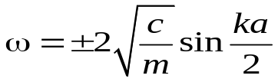. (3.10)

This dependence is shown in Fig. 3.3, c in the range of wave vector values of −π/а ≤ k ≤ +π/а. A positive value of k corresponds to the waves, propagating in the positive x-direction, while a negative k corresponds to the waves, moving in the negative x-direction. This restriction of wave vector in the space by the interval (−π/a…+π/a) is due to a discreteness of oscillating system (in which no waves, which length is less than 2a, are possible). Indicated range of wave vector values is a first Brillouin zone.
If the displacements of atoms are perpendicular to the direction of wave propagation, i.e., х ⊥ k, Fig. 3.3, d, the waves are called as transverse ones. These waves have the same dispersion law, as the longitudinal waves, but their frequency is lower. Maximal frequencies of longitudinal and transverse waves are located on the Brillouin zone boundary: 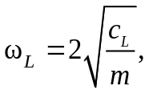 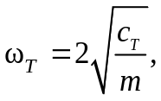 where с_{L} and с_{T} are the stretching and the bending elasticity, respectively. These frequencies, for most of crystals, are situated in the range of 10¹²…10¹⁴ Hz (cut-off frequency of elastic vibrations of atoms in a crystal is called the Debye frequency).
In the case of small wave vectors, that is, in a long-wave approximation, when k → 0 and λ → ∞ (near a centre of Brillouin zone), the value sin(ka/2) → ka/2, and a phase velocity of waves is almost equal to their group velocity; consequently, spatial dispersion is practically absent:
υ_{ph} = ω/k = 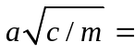 dω/dk = υ_{gr.}

In the event of large values of wave vectors k (a short-wave approximation, near the Brillouin zone boundary), these velocities vary considerably. A spatial dispersion takes place, so at zone boundary υ_{gr} → 0.

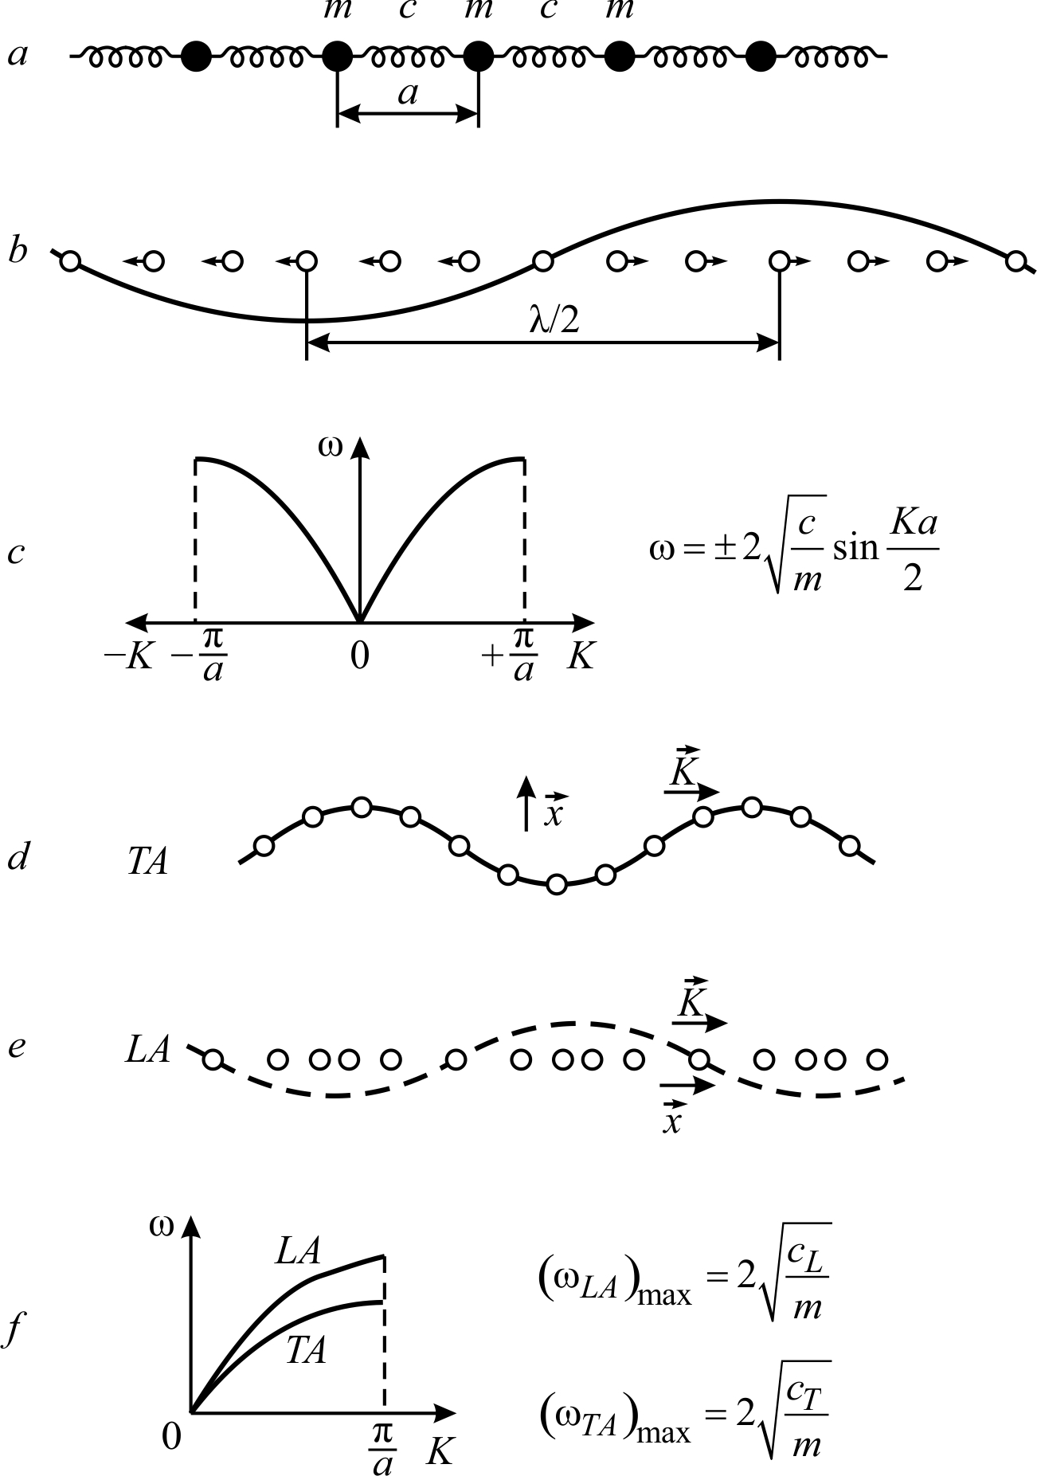
Fig. 3.3. Elastic waves in one-dimensional atomic crystal: a – chain of elastically coupled atoms;
b – longitudinal elastic wave; c – wave’s dispersion in a first Brillouin zone;
d – transversal acoustic wave; e – longitudinal acoustic waves,
i – dispersion law (the "branches" of acoustic waves)

In physics and application of crystals, it is important, that elastic displacements of atoms determine a feature of sound waves propagation: υ_{gr} corresponds to the sound (or ultrasound) velocity. Therefore, crystal vibration modes, that are characterized by a dispersion law (3.10), are called as acoustic modes. Main acoustic waves are marked in the Fig. 3.3 in such a way: LA – longitudinal acoustic waves, TA – transverse acoustic wave. A quantization of the elastic waves is associated with the concept of quasi-particles – longitudinal and transverse phonons. Wave packets of crystal lattice elastic vibrations are called as phonons by an analogy with photons (which are quanta of the electromagnetic waves).
The curves LA and TA in Fig. 3.3, f characterize the branches of phonon modes in a first Brillouin zone, and they show a relationship between the frequency ω and the wavelength λ = 2π/k in a crystal. Monochromatic acoustic waves can be excited in crystals by using piezoelectric vibrators. However, at nonzero temperature, a lot of chaotic acoustic waves exist in a crystal (with a wide distribution of their frequencies and wave vectors); these phonons represent a thermal reservoir of crystal lattice.

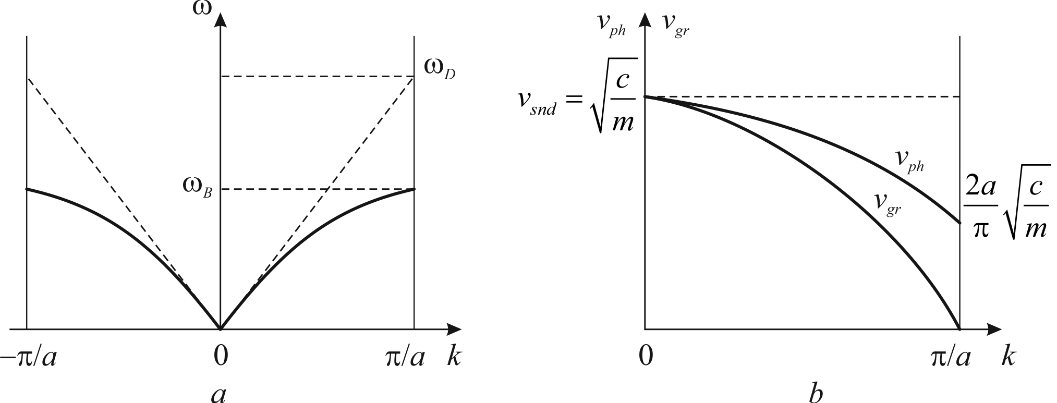
Fig. 3.4. Characteristics of phonons for one-dimensional chain of atoms in the model Born:
a – branches ω(k) for waves, propagating in positive (k > 0) and negative (k < 0) directions,
in comparison with dotted line, that shows ω(k) for Debye model; b – phase and group velocities dependence on wave number.
During acoustic vibrations in the ionic crystals, a cation-anion unit cell is moved as a whole, i.e., adjoining cation and anion (represented one unit cell) are shifted in a same manner; such a movement does not change any electrical fields in the system. That is why, not only in the atomic lattice, but in the ionic crystals the acoustic vibrations of are "electrically inactive", since in this event an electrically neutral elastic shift occurs: this is a movement of centres of masses. A dispersion law of the acoustic phonons in the ionic crystal is described by the equation (3.10), that corresponds to the first quarter of sinusoids, Fig. 3.4, d.
As it was mentioned, a maximal frequency of acoustic phonons is located on the boundary of Brillouin zone; according to Born models, this frequency ω_{B} is less than ω_{D} – maximal frequency in the model of Debye, Fig. 3.4, a. In addition, in both models, as the phase, so the group velocity show a dispersion, Fig. 3.4, b. At the boundary of the Brillouin zone group velocity is zero, while the phase velocity is only minimal.
Usually in crystals the chaotic acoustic waves exist (with a wide distribution in the frequencies and wave vectors), which are the thermal vibrations of crystal lattices. Thermal phonons are not ordered, but using piezoelectric vibrators applied to crystals it is possible to excite the monochromatic acoustic waves.
Acoustic vibrations of atomic lattices are "electrically inactive" (in the centre-symmetric crystals), because the elastic displace in this case occurs with electrically neutral (uncharged) centre of mass of unit cell. Accordingly, at acoustical oscillations, any electrical polarization does not arise (if a crystal is non polar).

The electrically-active are not the acoustic, but the optical phonons. In the simplest one-atomic crystal (considered in connection with Fig. 3.3 and 3.4), an elementary cell consists of only one atom, so optical phonons are absent: simplest one-atomic (or one-molecule) crystal holds only acoustic (longitudinal and transverse) phonons. However, in more complicated crystals (when unit cell contains two atoms and more), a displacement of particles within the unit cell is possible. Due to a very high elastic forces for such "counter" displacements, the frequency of these movements lays in the optical range (more precisely – in the infrared part of the optical range). Coordinated in many neighbouring elementary cells, these "internal" vibrations are the optical phonons.
Figure 3.5 shows an one-dimensional model of the ionic crystal – a linear chain of cations and anions, with selected unit cell lattice parameter a. In this model, as in the model, shown before (see Fig. 3.3), the acoustic vibrations LA and TA are also exist.

However, together with them, another type of phonons appears, namely, the optical phonons.
In the case of longitudinal optical waves (LO), a displacement of ions is parallel to the direction of wave propagation, i.e. х || k, Fig. 3.5, b. If displacements of ions are perpendicular to the direction of wave propagation, i.e. х ⊥ k, the waves are called as transverse ones, TO in Fig. 3.5, c. These waves have a similar dispersion law as longitudinal waves, but their frequencies are lower, Fig. 3.5, d (because elasticity at bending is less, than elasticity at stretching-compression). In this model, the acoustical oscillations LA and TA are also exist, but they are not shown in chain in Fig. 3.5.
Unlike acoustic frequencies, in the case of optical vibrational modes LO and TO, the spatial dispersion is an obvious characteristic in the whole Brillouin zone, Fig. 3.5, d. In this case, ions oscillations are determined by the elastic force, acting between the neighbour ions, and, therefore, a frequency is not strongly dependent on a wavelength. The frequency of optical oscillations (at variety of wavelengths) always corresponds to a far-infrared optical range (~ 10¹³ Hz).

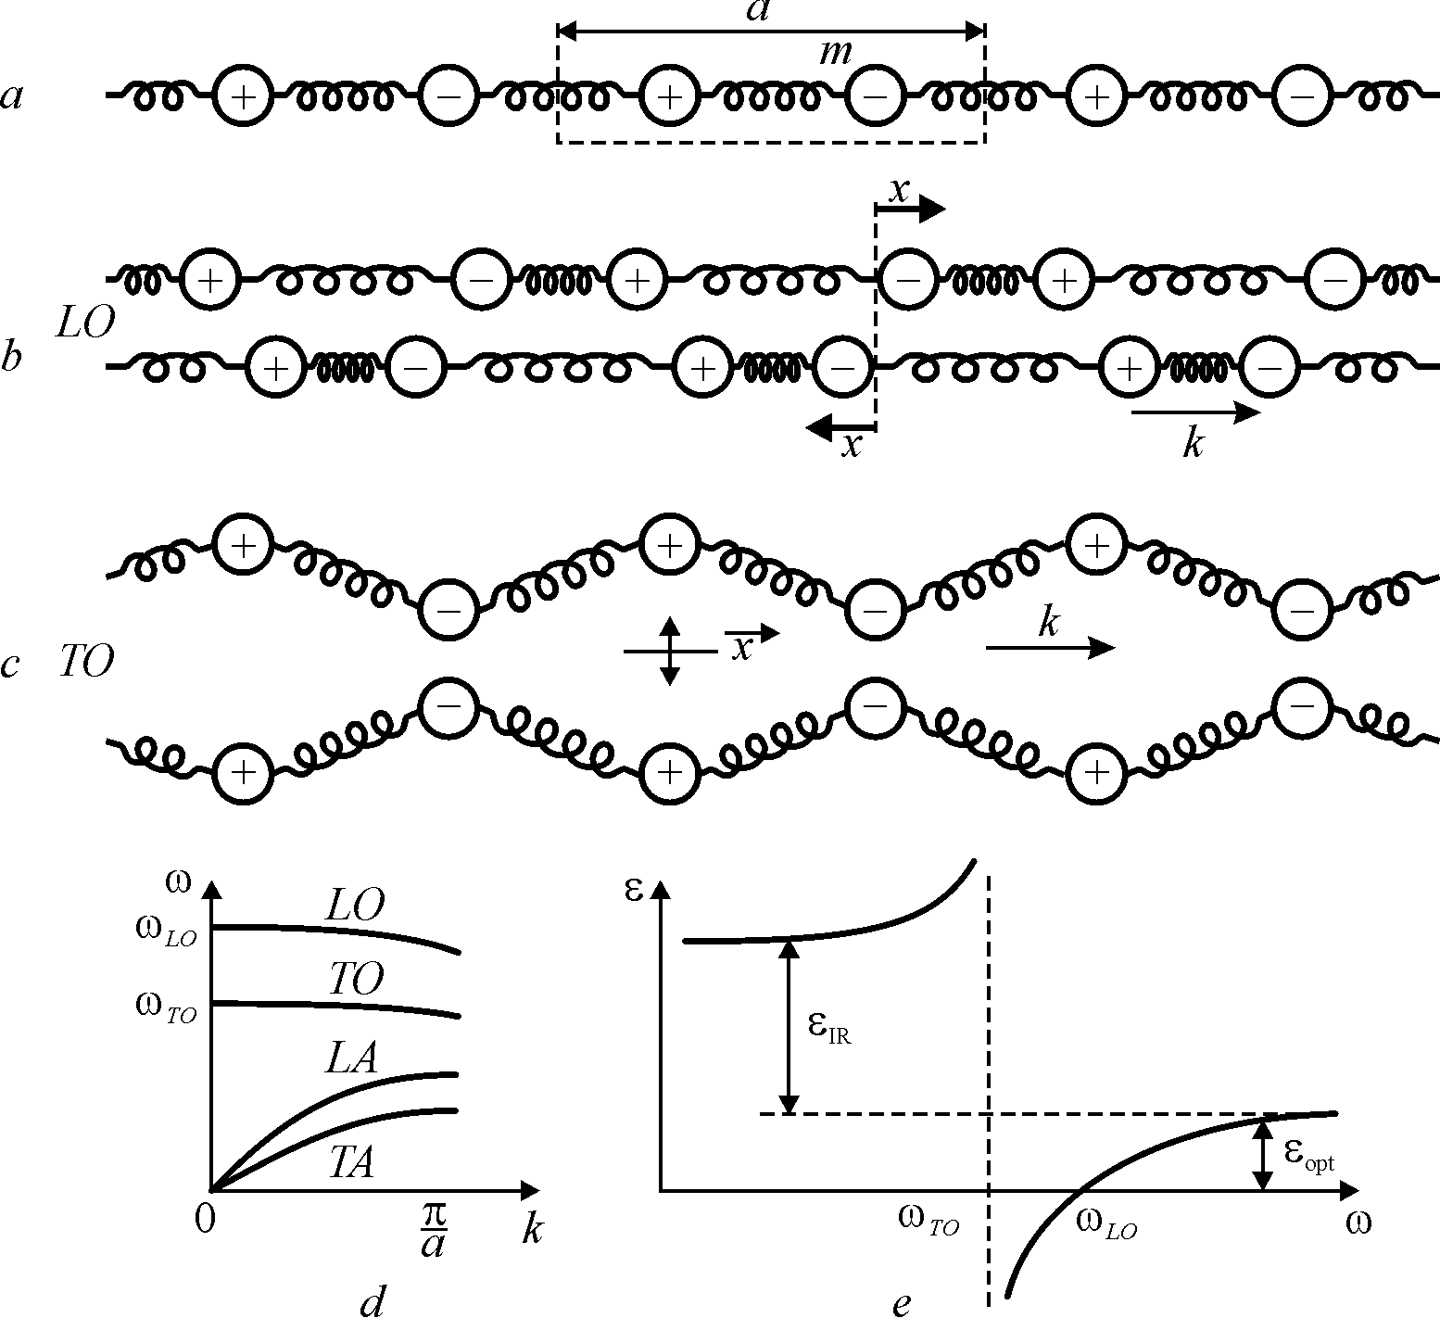
Fig. 3.5. Elastic waves in one-dimensional ionic crystal: a – chain of elastically bound ions;
b – longitudinal optical wave; c – transverse optical wave; d – dispersion law ("branches") of optical and acoustic waves; e – frequency dispersion of permittivity

When the wave vector is reduced (k → 0, that means λ → ∞), the frequencies of optical branches LO and TO do not decrease (as in the case of acoustic phonons); moreover, these frequencies even increase up to the limits of ω_{LO} and ω_{TO}.
The permittivity dispersion in the range of far-infrared (IR), at first, shows an increase in ε(ω), and then, at the frequency ω_{TO} permittivity ε falls sharply to the negative values (Fig. 3.5, e) that corresponds to the model of the oscillator:

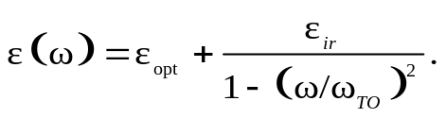 (3.11)

Resonant frequency of this oscillator is ω_{TO} (which is a frequency of transverse optical phonons), while a longitudinal optical frequency ω_{LO} corresponds to the equality: ε(ω_{LO}) = 0, Fig. 3.5, e.
To describe optical vibrations by the oscillator model, besides the strength of inertia m(d²x/dt²) and elastic returning force cx, it is necessary to consider an electrical force of ions interaction qF, where q is charge and F is microscopic Lorentz field:

m(d²x/dt²) = – сх + qF.

In the polarized environment, a field F differs from an average macroscopic field E: F = E + P/(3ε₀), as it will be shown in Section 6.2. For transverse optical vibrations the elastic displacement vector is perpendicular to direction of the wave propagation (x⊥k), so, an average, the macroscopic field E = 0, since the adjacent "combs" of the polarization waves are different in their polarity (Fig. 3.6, a). Consequently, in the equation (3.11), written for a transverse mode, it is necessary to substitute: 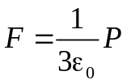. Polarization, as usual, can be expressed in terms of induced dipoles that have density N and dipole moment p = qx, so P = Nqx. As a result, an oscillator equation takes the form
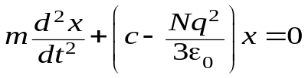,
where the intrinsic frequency of the oscillator, which corresponds to the frequency of the transverse optical phonons, is
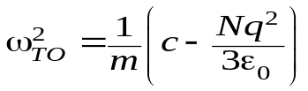. (3.12)
Thus, Lorentz field F reduces an elastic constrain, and, accordingly, decreases oscillator frequency ω₀ = (c/m)^{1/2} to the frequency of transverse optical phonons, i.e. promotes "softening" of vibrations (reducing frequency ω₀ of oscillator: ω_{ТО} < ω₀). This event is associated with the polarization of a "short-circuited" crystal, when D = P, since D = ε₀E + Р and E = 0.
In the case of the longitudinal oscillations, local Lorentz field is significantly different (Fig. 3.6, b), since an electrical field E is directed opposite to polarization P: ε₀ Е = − P. In the macroscopic theory this case corresponds to an "open-circuited" crystal with the induction D = ε₀E + Р = 0. Taking into account Lorentz field in the equation (3.11), for longitudinal waves it is possible to have:
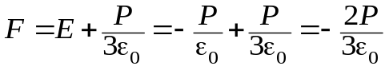.
Corresponding equation of the oscillator, taking in consideration P = Nqx, acquires a following form:
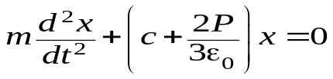.

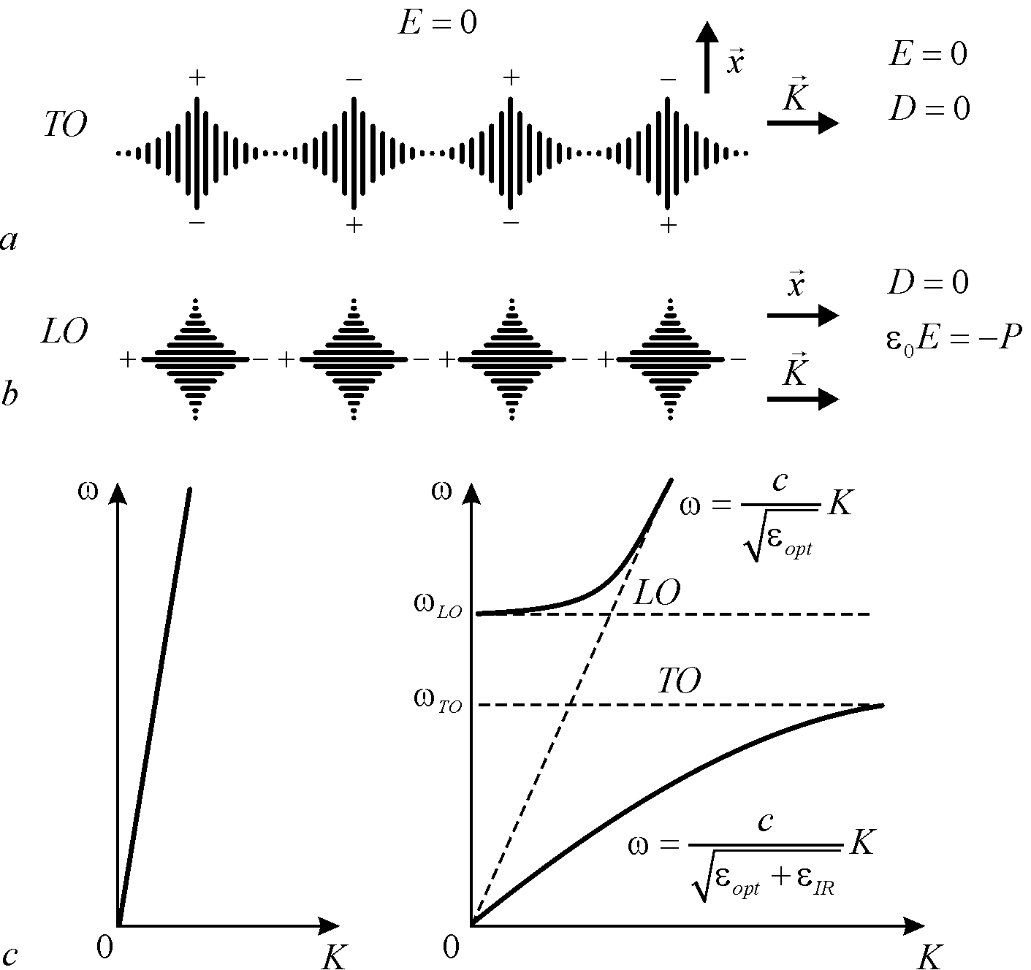

Fig. 3.6. Lattice elastic waves and dispersion in one-dimensional model of ionic crystal

An intrinsic frequency of the oscillator, which corresponds to the longitudinal vibrations, is
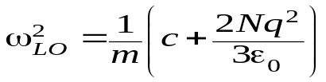. (3.13)
Therefore, a frequency of oscillator, which characterizes longitudinal optical vibrations in the polarized medium, is higher, than the frequency of isolated oscillator (ω₀ = (c/m)^{1/2}). Results, obtained in the equations (3.12) and (3.13), explain the location of the phonon branches: LO lies over TO, and position of two characteristic frequencies ω_{LO} and ω_{TO}, Fig. 3.5, d.
Permittivity of ionic crystals depends on a difference in frequencies of longitudinal and transverse optical vibrations ω_{LO} and ω_{TO} in the centre of the Brillouin zone. Equation, that describes an infrared polarization of ionic crystals, maintains the frequency of transverse optical phonons in the long-wave limit:

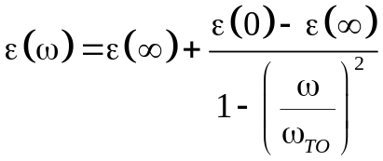,
Correspondent dielectric contribution of ionic polarization is:

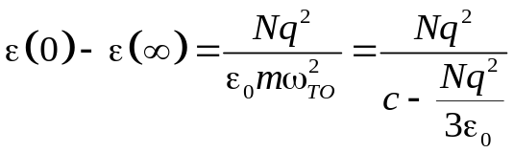. (3.14)
This equation implies, that ionic polarization effects on dielectric properties of crystals is the stronger, the higher is the ionic charge q, and the less is elastic coupling coefficient of ions c.
Expression (3.14) allows quantitative calculation of infrared contribution to the dielectric permittivity. Indeed, an ions concentration N can be found accordingly to the density of a crystal, m is the reduced mass of vibrating ions, q is ionic charge, and ω_{TO} is a frequency of "residual" rays, which can be determined experimentally by the infrared waves reflections from a surface of studied crystal. Coefficient c, that describes an elastic coupling of ions, can be calculated from the macroscopic elastic properties.

As an example, experimental data on phonon dispersion in a simple two-ions crystal NaI is shown in Fig. 3.7, a,. These data are compared with dispersion in the diatomic crystal diamond, Fig. 3.7, b. It is noteworthy, that in ionic crystal of sodium iodide in a centre of Brillouin zone (q = 0) the frequencies of longitudinal and transverse optical modes are significantly different: ω_{LO} > ω_{TO}, whereas in the case of diatomic crystal they are the same: ω_{LO} = ω_{TO}.
The comparison of heat capacity theories, given by Einstein and Debye, shows that Debye approximation much better describes the temperature dependence of the specific heat C(T), especially at low temperatures (see Section 2.7). This can be explained by taking into account, that a spectrum of atoms vibrations in crystals consisting of optical and acoustic branches. Obviously, the Einstein's theory describes better the optical branches of vibrations, for which a frequency dependence from temperature is observed in a much narrow interval of wave vectors, than in the event that acoustic branches. In addition, in the case of low temperatures, mainly excited are the acoustic phonons, whose spectrum is satisfactorily described by the Debye theory.
It should be noted, that even at low temperatures, many phonons exist in crystals: for example, at a temperature close to one-tenth of Debye temperatures (in the vicinity of 20...50 K) one cubic centimetre of solids contains for about 10²⁰ phonons (recall that 1 cm³ accommodates about 10²³ atoms). As a temperature increases, the concentration of phonons increases hundreds of times, with the increase of their average energy.

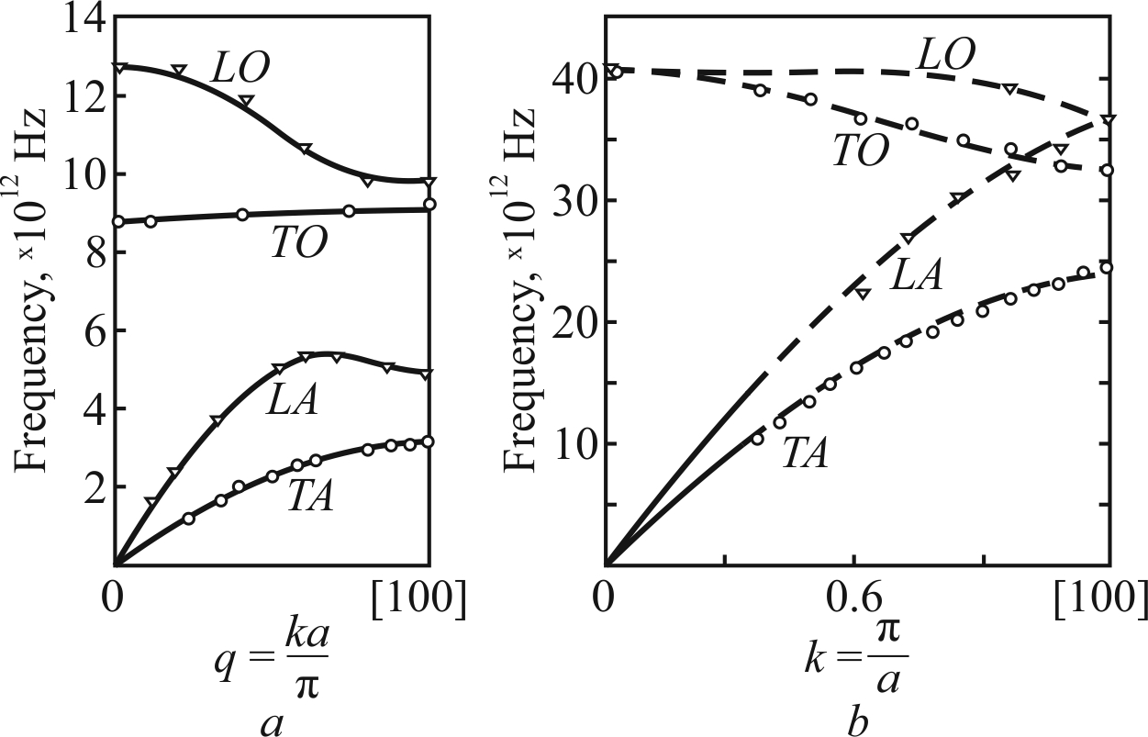

Fig. 3.7. Phonons frequency dependence on a wave vector in the direction [100] for two-ionic crystal NaI (a) and diatomic crystal diamond (b); q = ka/π – normalized wave vector

Elastic waves in the crystals are more diverse and complex, as compared to other environments. In a gas (in air, for example) or in a liquid, the only fluctuations of density (or pressure) are possible – i.e., the longitudinal sound waves. But in solids, in addition to these waves of density fluctuations, the shear (transverse) waves can move. In the event that density waves, atoms oscillate along a wave vector k (longitudinal waves) while in case of shear waves the atoms oscillate in a plane, perpendicular to the wave vector k (transverse waves). Note, that in low-symmetry crystals the two types of transverse waves can exist.
In general, in a crystal, 3ξ types (modes) of particles oscillations can propagate, where ξ is a number of atoms (or ions) in the unit cell of crystal. For example, in NaCl crystal a unit cell contains two ions (ξ = 2), so the 3×2 = 6 types (modes) of elastic waves can propagate, while in the metallic sodium, where a unit cell has only one atom Na (ξ = 1), the only three modes of vibrations exists.
Of the 3ξ types of waves, three are the acoustic waves. Their distinctive feature is that in the case of small wave vectors (i.e., large wavelengths) acoustic waves have small frequency; for very small values of the wave vector k (when it goes to zero) the frequency acoustic vibrations also appeals to zero. Other (3ξ – 3) types of waves are the optical waves, because these waves were first detected by optical methods. As already mentioned above, the optical waves frequencies ω_{LO} and ω_{TO} are maximal, when the wave vector k tends to zero.

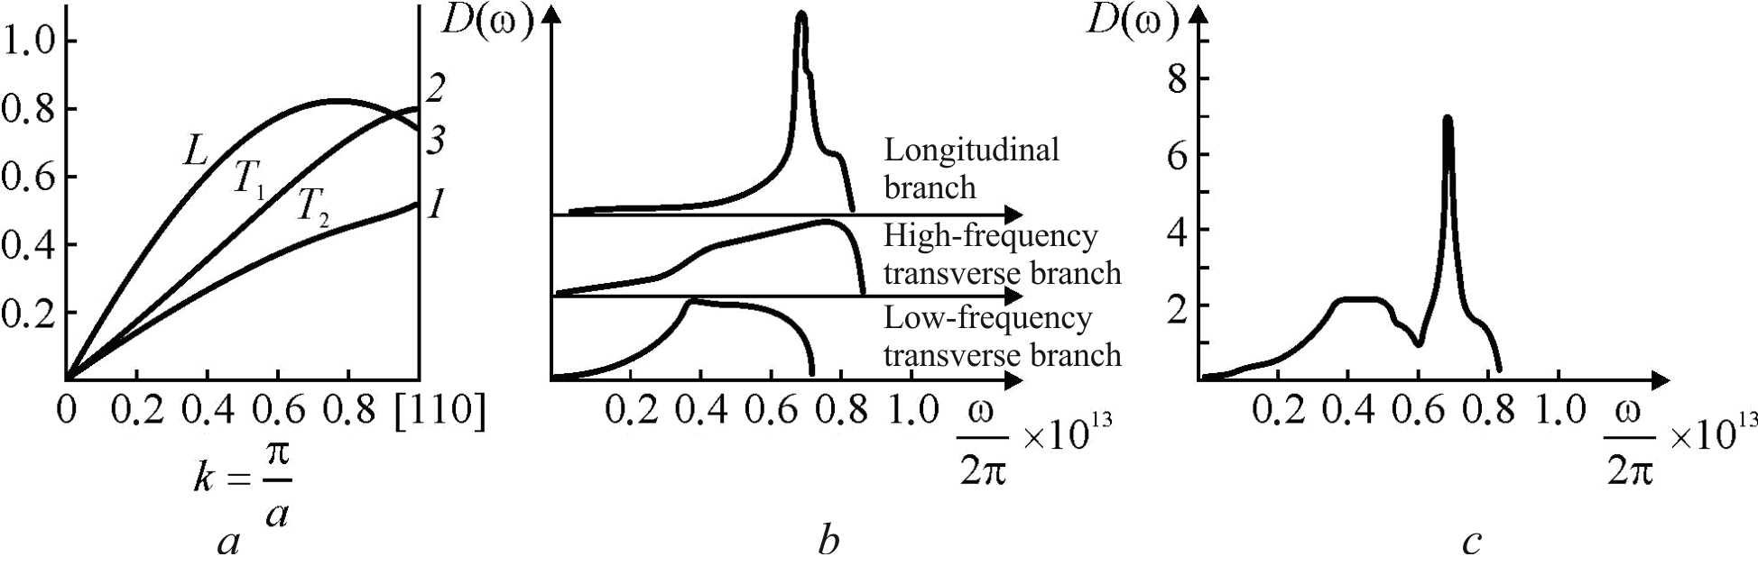

Fig. 3.8. Oscillatory spectrum of aluminum: a – phonons branches in the Brillouin zone;
b – function D(ω) for longitudinal and transverse branches; c – total view of D(ω) function

Each of 3ξ dependences of ω_{j}(k) type (j enumerates indexes: j = 1, 2, ..., 3ξ) are periodical function of its argument. This periodicity is a manifestation of the general properties of crystals, and reflects periodicity in the arrangement of atoms in the real space; this results also in a periodic arrangement of cells in the "inverse” k-space (the dimension of k is [m^{–1}]). In summary, all consideration of the crystal lattice vibrations can by limited by one unit cell in the first Brillouin zone.

Quantization of elastic waves corresponds to a concept of the quasi-particles – longitudinal and transverse collective displacements of lattice atoms. The knowledge of phonon spectra is necessary to analyze and calculate many physical properties of solids – optical, thermal, electrical, and so on. In experiments, the dispersion curves of longitudinal and transverse waves usually are determined in the directions of highest symmetry. Then this information is used to calculate the numerical density of states. To interpret the spectra of oscillations, a very important step is to analyze the critical points.
Calculations of the density of states of a spectrum are shown in Fig. 3.8 for aluminium. Sharp maximum in total dependence of states density D(ω) corresponds to a maximal frequency of certain types of phonons. In crystals with complex many-atoms lattices these peculiarities in spectrum may be associated also with optical branches of vibrations. Figure 3.9 shows optical absorption in the silicon crystal, which is a function of phonon spectrum. The sharp highs on the curve relate to violation of various modes of atoms vibrations the silicon.

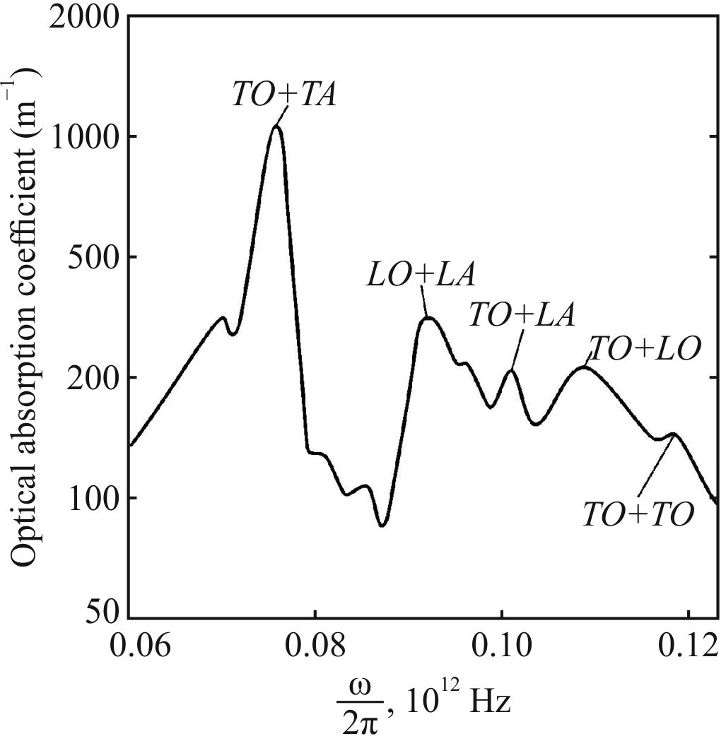
Fig. 3.9. Spectrum of phonons absorption for silicon (Si) crystal

When phonons are compared with particles, it should be noted that the number of particles in a collision remains, but at the collisions a number of phonons is not saved. However, the main difference between phonons collisions from the ordinary particles lies in the fact, that while collision of phonons the impulse is not conserved. Possible phonon collision is schematically shown in Fig. 3.10.

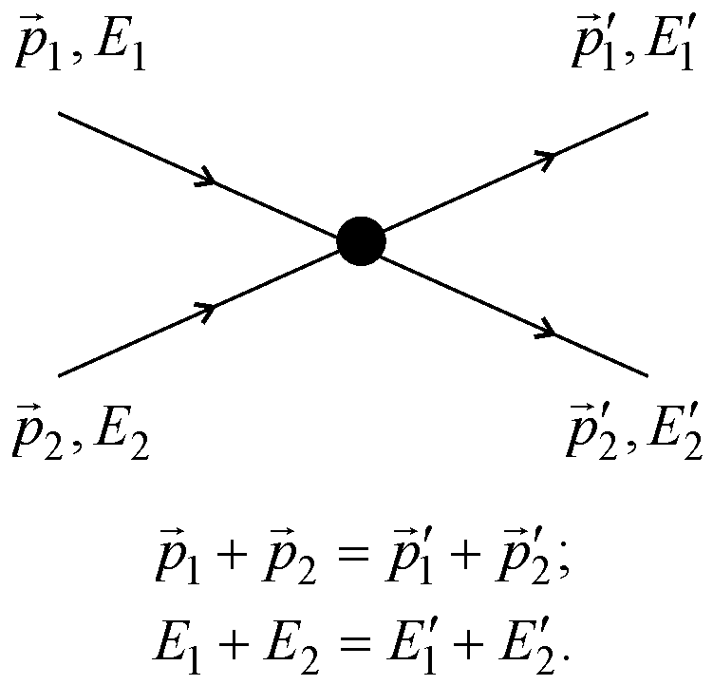

Fig. 3.10. Saving energy and impulse in collisions of phonons

Since most of phonons determine the thermal properties of solids, so, while studying heat capacity and heat conductivity, it is possible to get information about the properties of phonons. Moreover, acoustic phonons investigation at small pulses is relatively simple, as they are ordinary sound waves. Studying the experimental data on the velocity and attenuation of sound in the crystals, it is possible to obtain the characteristics of long-wave acoustic phonons.
In order to study the long-wave optical phonons, the investigation of resonant absorption of light by crystals is used (at that, falling on a crystal photon is converted into phonon). Since the velocity of light is very large, an optical phonon is born with a very small impulse. Therefore, by the optical research, the data can be obtained only for phonons near the centre of the Brillouin zone.
The inelastic neutron scattering in crystals gives the most detailed spectrum of phonons branches. Flying through the crystal, a neutron excites vibrations of atoms while slightly reducing its energy. It might be say, that a neutron "gives birth” to phonons. The larger is the way, that neutron passes in the crystal, the greater is the probability of phonons birth. Thus, studying an inelastic neutron scattering, it is possible to find directly phonons dispersion law in the entire Brillouin zone.

3.6. Magnons
Besides the charge and mass, the elementary particles (electrons, protons or neutrons) are characterized by a spin, which determines their magnetic and mechanical properties (word spin means "rotation", or "spindle"). Thus, the particles can not be imagined as the "fixed balls." If use a classic concept, these particles would be as "rotating balls". The rate of this rotation can not be changed, because that, what simplistically is interpreted as a "rotation", really is an intrinsic property of a particle itself. The electron or the proton can not change a value of their spin, as well as a value of their mass or charge.
A classical idea of spin is an extreme simplification, and this conception contradicts to the theory of relativity. In fact, the spin is not a consequence of spatial rotation, but a certain property of elementary particle, which determines, in particular, its treatment in the "collective" of surrounding particles. Spin of one kind of particles can be only integer-valued, but for others – just half-integer. Zero spin is referred to the integer spin.
The magnitude of a spin is denoted by the letter s. Particle with a spin s is a particle with angular impulse: [s(s + 1)]^{1/2}ħ. Electron has a spin equal to ½. Since the electron has an electrical charge e, it is a source of electrical field. In connection with "rotation" of charged electron (which in classical physics may conventionally considered as a circular current), the electron is also a source of magnetic field. The particle with a spin ½ of and electrical charge e has magnetic moment
μ_{B} = еħ/2тс.

This value, called as Bohr magneton, is about of 10^{–20} erg/Gs. Discussing the magnetic properties of solids, it should be noted, that a magnetic moment of electron is an unusual vector, because it can have orientation in a space only by two ways: lengthwise the field or against it. Accordingly, an angular momentum of the particle always can be orientated by g = 2s +1 manners; inasmuch as electron’s spin is s = ½, only two of these manners are possible. Spins characterize not only elementary particles, but the quasi-particles as well. Photons and phonons are also characterized by the integer spin (they are bosons). Bosons include also the magnons.
Magnon (spin wave) is a quasi-particle, introduced in theory to describe the system of collective excitations of interacting spins in the magnetic crystals (ferromagnetics, antyferromagnetics and ferrimagnetics). A thermal motion and magnetic field can influence on magnetic moments of electrons orientation. However, the localized (single) inverted spins can not exist in a ferromagnetic – this case is prevented by the exchange interaction. That is why, the elementary excitations in a ferromagnetic (as in other magnetically ordered substances) are inverted spins, distributed in a certain section of a crystal.
These violations have the nature of waves, that are characterized by certain wave vectors k and frequencies ω. Such violations are called spin waves (magnons). They exist in the ferromagnetics at any temperature, lower than Curie temperature (as well as in the antiferromagnetics – below Neel temperature); magnons intensity is greater, the higher is the temperature.

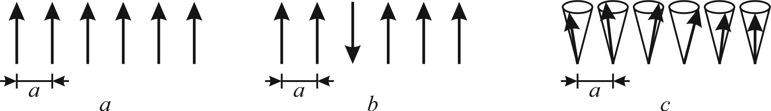
Fig. 3.11. Different ideas about spin waves in one-dimensional lattice with parameter a:
a – classical scheme of ground state of a simple ferromagnetic – all spins are parallel and
directed in one direction; b – simplest idea of excited magnetic state – one inverted spin;
c – spin wave in ferromagnetic
Single magnon corresponds to a wave of neighbouring spins rotation. Idealized picture of spins excitation in the one-dimensional crystal is shown in Fig. 3.11. The model of one upturned spin among some others spins (Fig. 3.11, b) is less likely, because such situation requires a significant cost of energy. The much less energy needs, if suppose, that all the spins are directed, predominantly, in parallel, as it is shown in Fig. 3.11, c. Therefore, this is a more realistic model, according to which the ends of spins vectors precess on the surface of a cone, so each next spin is shifted in phase as to previous spin (angle between them remains constant).
Wave is formed due to a strong exchange interaction between atoms; as a result, a deviation of the magnetic moment of any atom from equilibrium position is not localized, but is distributed in the environment. Spin wave may occur, mainly, in the magnetically ordered solids – ferromagnetics, antiferromagnetics and ferrimagnetics. At that, in the crystals with multiple submagnetic lattices (i.e., in antiferromagnetics) there may be several types of magnons with different energy spectra.
Figure 3.12 shows a model of magnon – spin wave, which in its structure resembles a wave of acoustic phonon (shown in Fig. 3.3). A series of atoms is shown, and the distance between them is a crystal lattice parameter. In the magnetic field H all spins precess with a frequency ω₀ (homogeneous precession). In the real systems, the small oscillations of magnetic moments of atoms are realized in the form of waves with inhomogeneous precession.
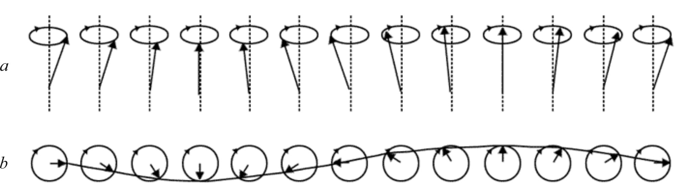

Fig. 3.12. Spin wave in linear series of spins: a – series of spins shown from side; b – series of spins shown from above (wave is shown as a line that runs through the end of the spin vectors)

It should be noted, that magnons, as waves of electronic spins precession in the neighbouring atoms, differs significantly from phonons, which are generated through the elastic displacements of atoms. This is seen in the dispersion law of magnons – a dependence of energy Е = ħω on impulse р = ħk (or, equivalently, a dependence of magnon frequency ω = 2π/T of a wave vector k = 2π/λ). The dispersion law for spin waves for one-dimensional model is expressed as follows:

ω = 8JS/ħ sin²(ka/2),

where J is an exchange integral; S is spin moment; a is crystal lattices parameter. Graphically dispersion of magnons is shown in Fig. 3.13.
In the case of magnons in a one-dimensional chain of atoms, another dispersion law is valid: ω = 2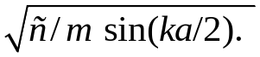For the long waves of phonons (k → 0), a frequency is proportional to the wave number: ω ~ k. However, for the long waves of magnons (k → 0) the dispersion law is parabolic: ω ~ k². Just this frequency dependence of magnons is observed in the experiments, using neutron scattering in the magnetic environments, Fig. 3.13, b.

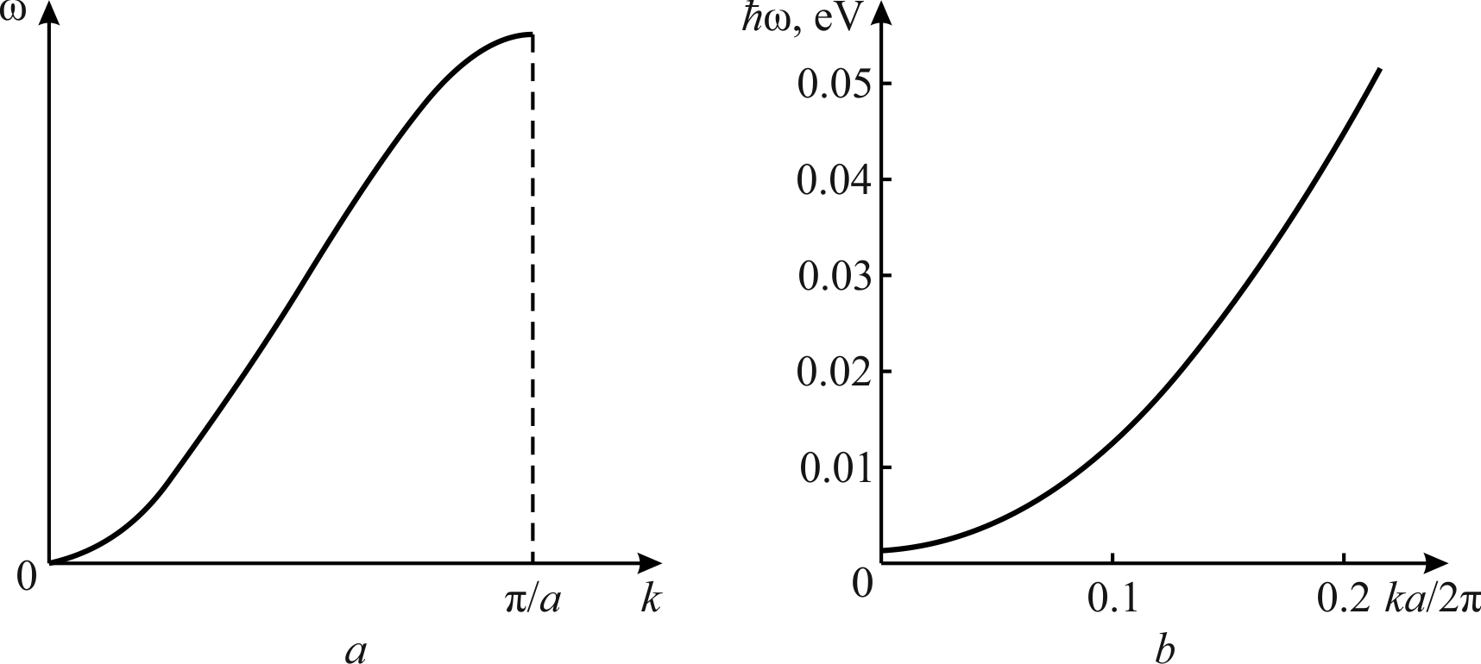

Fig. 3.13. Dispersion law for spin waves in one-dimensional ferromagnetic:
a – theoretical calculation; b – magnon spectrum measured in alloy Co_{0.92}Fe_{0.08}
Thus, magnons characterize a movement of elementary magnetic moments in the magnetics. As phonons, magnons are excited by thermal motion of atoms or ions in the magnetics. In addition, the long-wave magnons can be excited by an electromagnetic field of ultrahigh frequency. Magnons behave as weakly-interacting quasi-particles; they are characterized by the integer spin (equal to unity) and hence they obey Bose-Einstein statistics. Calculations show, that at high temperatures a concentration of magnons in the ferromagnetic crystals is significant. Their density in ferromagnetics n_{fer} proportionally increases with temperature, and depends on the remoteness from Curie point: n_{fer} ∼ (T/T_{C})^{3/2}. In the antiferromagnetics this dependence is different: n_{anti} ∼ (T/T_{N})³, where T_{N} is the Neel point.
At very low temperatures (near absolute zero) ferromagnetic reaches the lowest energy state, in which the atomic spins are oriented in one direction. Therefore, magnons at temperature lowering freeze out, so near the absolute zero magnons are practically absent. A corresponding effect of Bose-Einstein condensation is confirmed experimentally. Growth of magnons quantity caused by temperature increase reduces magnetic ordering in crystal.
In a antiferromagnetic, the number of magnons is proportional to T³, that reminds a Debye law for temperature dependence of phonons concentration. However, in the ferromagnetic, the concentration of magnon increases proportionally T^{3/2}. The point is that the increase in magnons number decreases the spontaneous magnetization of ferromagnetic, in which connection a change of magnetization is proportional to T^{3/2} (Bloch law). Correspondingly, a dispersion law for magnons in the antiferromagnetics differs from the magnons dispersion in the ferromagnetics, Fig. 3.14. In this case, the variance is similar to phonons dispersion (see Fig. 3.3, c).
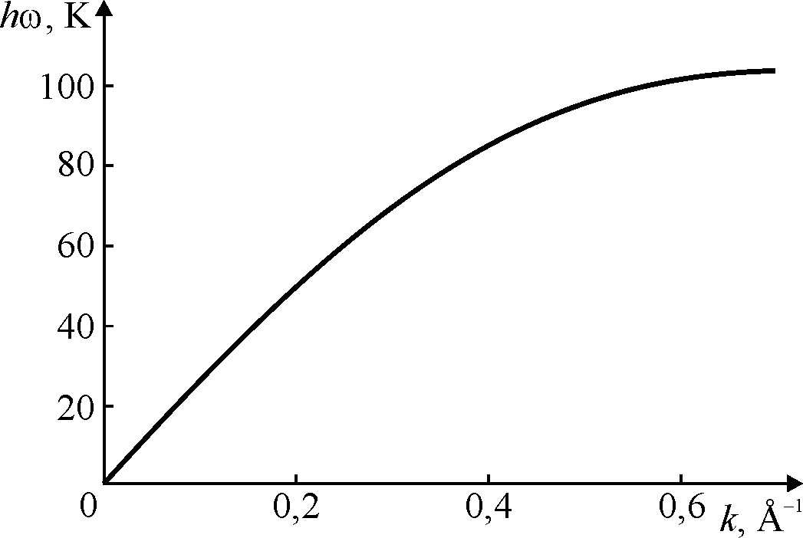
Fig. 3.14. Spectrum of spin waves in antiferromagnetic RbMnF₃, obtained by inelastic neutron scattering
Therefore, the properties of ferromagnetics below a Curie point (as well as antiferromagnetics – below a Neel point) is convenient to describe, assuming that the spin waves exists, which can be represented by almost degenerate gas of magnons. A chemical potential of this gas is zero, and, therefore, a number of magnon is not saved. Bose distribution function for the magnons energy allows to calculate temperature dependence of thermodynamic properties of magnetics (magnetization, heat capacity, magnetic susceptibility). The resulting expressions are the more accurate, the closer gas of magnons is to the ideal Bose gas. Deviations from theory are a result of magnons interactions with each other as well as interactions with other quasi-particles (phonons, electrons). As temperature increases, the number of any quasi-particles grows up, and, therefore, their interaction becomes so significant, that a suppose “perfect gas of magnon” ceases to be fair.
Magnons conception allows to describe many properties of magnetics – not only their thermodynamic (equilibrium) properties, but the kinetic and resonance properties as well. For example, magnons take a significant part in a heat capacity of the magnetics along with phonons and electrons (for metals) – Fig. 3.15. With increasing temperature, the spins are increasingly begin to deviate from a mainstream, raising the internal energy and reducing the overall magnetization. In other words, perfectly magnetized at absolute zero temperature ferromagnetic can be represented as a state, when all magnetic fluctuations are "condensed". The appearance of some spins, which do not correspond to a general direction, can be represented as "gas of quasiparticles” – magnons. Each magnon reduces a number of oriented spins and lowers the magnetization of ferromagnetic.

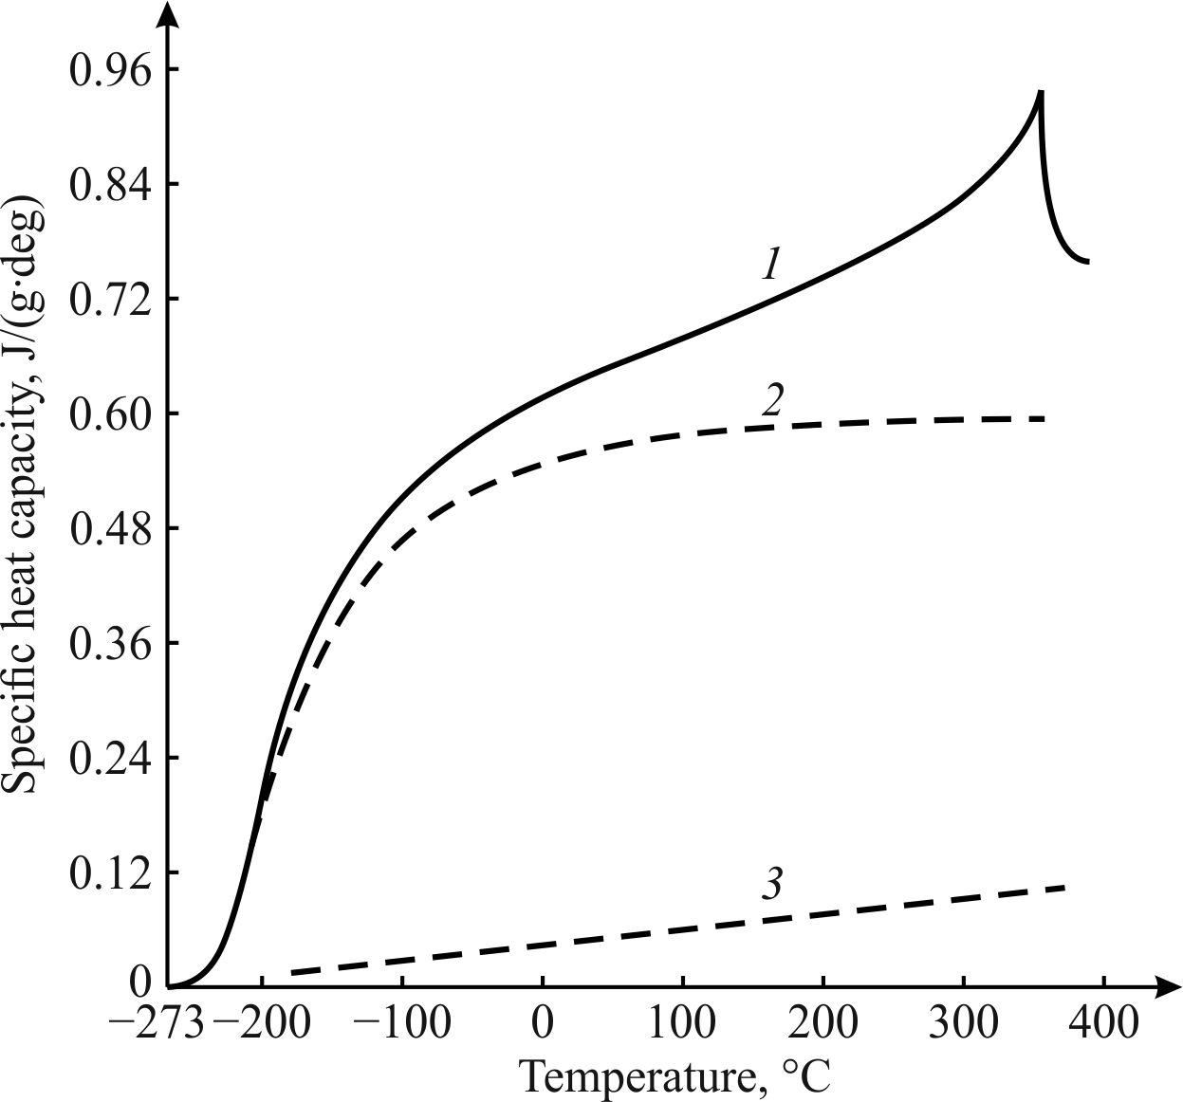

Fig. 3.15. Temperature dependence of different contributions to heat capacity of nickel:
1 – total heat capacity, 2 – lattice (phonons) heat capacity; 3 – electronics heat capacity
A concept of "spin waves" is broader than the concept of "magnons". Spin waves can exist in the nonmagnetic metals as well; they represent the spin density oscillations of conductive electrons due to energy exchange and interaction between them. The existence of spin waves in the nonmagnetic metals is found in some features of electronic paramagnetic resonance, particularly, in the transparency of selective metal plates for electromagnetic waves at frequencies, close to resonant frequency.

3.6. Electrons in atoms and in crystals

It is advisable to start electronic states consideration in the crystals with electronic spectra of atoms. Atoms can be characterized by two complementary models: space and energy. The spatial model of the atom reflects its volumetric three-dimensional structure, and, within this structure, a probability density of electrons location in an atom. Electrons, distributed near the nucleus, are called as electronic cloud. In the simplest case, this cloud is spherical (i.e., for hydrogen atom in the non-excited state), but in the most cases electronic cloud has a complex configuration.
A conventional image of electronic cloud external shape is widely known for different quantum states (see Fig. 1.3). Schrödinger equation allows to perform a rigorous mathematical description of these geometric features of electronic clouds of atoms and ions. However, sometimes their visual representation is impossible, since to find a probability of electrons distribution in a cloud might be quite difficult. Therefore, to describe the atom, a simplified model is often used – a model of Bohr. This model allows to present atom as a central nucleus and electrons, moving in orbits around it.
A number of electrons determines the position of atom in periodic Mendeleev table, and it is exactly equal to the number of protons in the nucleus of an atom. From experiments and theory, it is known, that the radius of atom a ≈ 10^{–8} cm. At that, the size of the nucleus is near 10^{–13} cm, and roughly the same is the size of an electron; thus, the size of an atom in a hundred thousand times greater, than the size of its nucleus. Therefore, on the face of it, the volume of atom looks like "empty", but in many sections of solid state physics atom is represented as a solid ball, and this is a “good working" model. The question is that this “ball” is “filled” by a very strong electromagnetic field.
Next, to simplify further consideration, a simplest atom is discussed; namely, the hydrogen atom, consisting of one electron and one proton. In this atom a positively charged nucleus holds the negatively charged electron by a Coulomb force of attraction:
F_{Coul} = e²/a,

where e is electron’s charge (same charge has a proton). For the stability of the atom, the force of gravity must be balanced by the repulsion force. This force is centrifugal force:
F_{centr} = mυ²/a,

where m is the mass of electron and υ is a velocity. The equality of F_{Coul} and F_{centr} forces makes possible to determine electron movement velocity on its circular orbit:
υ = (е²/mа)^{1/2}.
As charge e, so mass m of electron are the fundamental constants. Substituting these constants in a given formula, it is possible to find velocity of electron rotation in its orbit: υ = 10⁸ cm/s. Relativistic effects in these calculations is negligible, because υ/с ≈ 1/300. However, if the atom would have the size, close to its nucleus (10^{–13} cm), a velocity of electron’s rotation would be close to the velocity of light (obviously, this is impossible!).
The total energy of an electron in the field of nucleus (sum of its kinetic and potential energy) is:
Е = – е²/2а.

Sign "minus" means that for zero energy an electron should be taken, when it is sent away on an infinite distance from a nucleus (with decreasing distance, energy decreases).
According to a simple model, electron moves in an atom with a velocity of υ ≈ 10⁸ cm/s on the circle, so its velocity vector constantly changes its direction. Thus, there is a reason to believe, that Δυ ≈ υ: this means, that an uncertainty of velocity Δυ equals to velocity υ. From indeterminacy principle (in other words, uncertainty relation) Δx⋅Δp ≥ ½ħ; taking into account, that impulse is р = mυ, the uncertainty in the electron; s coordinates is Δx ≥ ħ/2mυ. From the mass of electron m ≈ 10^{–27} g, its velocity 10⁸ cm/s, and Plank constant, it is possible to find the electron location uncertainty as Δx ≥ 10⁻⁸ cm, which precisely matches the size of the atom.
This means, that a sphere of radius a has the volume, containing the electron, but to clarify its position in this volume is impossible. The quantum indeterminancy principle (Heisenberg principle) allows to estimate the size of an atom, namely, an atomic radius determines the uncertainty of orbital electrons position: а ≈ Δx ≈ ħ/mυ. Using this expression for the orbital velocity of electron υ = (е²/mа)^{1/2}, it is possible to get:
а = а₀ = ħ²/mе².

Thus, an atomic radius a₀ can be expressed through the fundamental parameters – Planck constant ħ, mass m and electron charge e. This radius that is approximately equal to 0.5∙10^{–8} cm and it is called the Bohr radius; it coincides with the radius of a hydrogen atom in its ground state.
According to quantum mechanics, not all states are allowed, but only the states with corresponding energies; there is one state (main), in which the electron does not radiate energy. In addition, besides the ground state with a Bohr radius a₀, there are also a number of excited states; the transitions between them result in the emission (or absorption) of light quanta. When the energy of electron is relatively large, the distance between energy levels are very small, and "jump" becomes similar to the permanent removal of an electron from the nucleus.
As electronic waves in the atom propagate in three dimensions, it is possible to depict them graphically only through the intersections, Fig. 3.16. The section shows two types of waves permitted (a and b) in the three quantum systems: the electron in a hydrogen atom (1), one-dimensional particle in a limited space (2) and quantum oscillator (3).

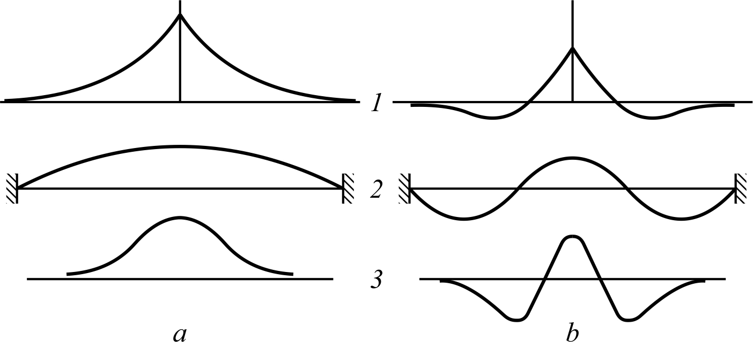

Fig. 3.16. Waveform probabilities for two allowed states electrons in atoms (1); for a particle that moves in a straight line (2), and for harmonic oscillator (3)
The fact that all electronic waves in atom have a "tail" that extends infinitely to large distance; figure 3.16, 1 shows that an electron can have some chance of staying in the space, but still most likely is its location near the nucleus. At that, the energy levels of electron, which correspond to its possible waves in a hydrogen atom (Fig. 3.16, 1 shows only two of them) can be placed in a series, that converges as shown in Fig. 3.17, b.

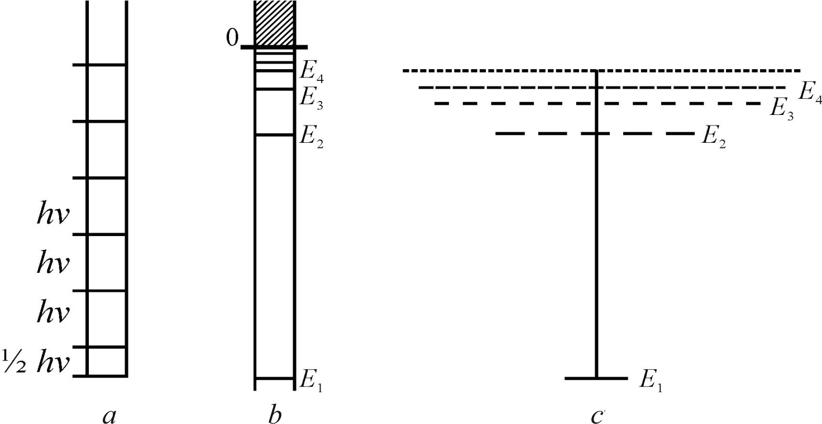

Fig. 3.17. Energy spectrum of quantum oscillator and hydrogen atom: a – allowed energy levels of quantum oscillator; b – allowed energy levels of electron in hydrogen atom; c – correspondent to the levels permitted states (number of strokes)
Unlike energy levels in the quantum oscillator, which distance from each other is always hν, a distance between electrons energy levels in atom decreases with energy increase. Therefore, getting enough energy, the electron can finally leave the atom, and next its energy changes continuously, as it is shown in the top of Fig. 3.17, b by the continuous energy spectrum. For “zero point” of energy just this state is selected, in which electron is found very far away from a nucleus.
When approach to each other, electrons fall into influence of electromagnetic field of the adjacent electrons (even without outside magnetic field). Therefore, electrons interact with each other, as well as two small magnets interact. The Pauli principle lies in this: if two electrons are in one of same steady state (for example, in one orbit), they can not have spins, oriented in one direction, but necessarily must orient their spins in the opposite direction.

In a helium atom, both electrons in normal conditions are authorized by a state with a lower energy. Because both of them are in a same state, their spins, according to a Pauli principle, are opposed and form a complete s-shell, Fig. 3.18, a.
The lithium atom has three electrons; two of them choose complete s-shell, while a third electron would also acquire a condition with minimal energy. However, this case is prohibited by the Pauli principle, since the main (s-) state is already occupied by two electrons with opposite directions of spins. Therefore, the third electron in the Li atom reluctantly takes one of the following states, characterized by significantly higher energy, Fig. 3.18, b.

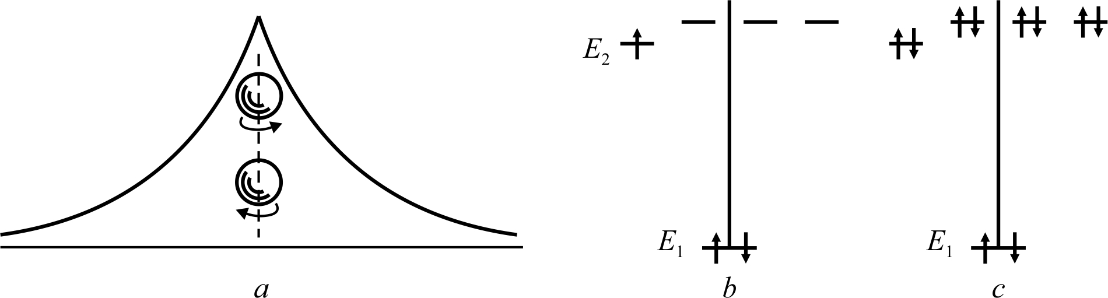

Fig. 3.18. Electrons and their spins in atoms: a – wave function for two electrons with opposite spins in a helium; b – basic (E₁ and E₂) levels in lithium (dotted line shows next higher allowed states); c – five levels in atom of neon, occupied by electrons

Lithium starts a new number of elements in the Mendeleev periodic system. The state, that had to take his third electron, is one of four possible states in the electronic p-shell, following the s-shell, Fig. 3.18, b. Each item in the next series of lithium gains another electron, and the electrons in such a p-state district are eight. They are all filled in the neon atom, Fig. 3.18, c: electrons occupy all four district states that are in the shell, and each of them contains two electrons with oppositely directed spins.
Condition of electrons in the atoms of a given element determines its physical and chemical properties. For example, chemically neutral inert gas argon has in its shell 18 electrons, but adding only one electron to shell (and one proton in the nucleus) transforms inert argon atom in chemically very active potassium atom.

Electrons in crystals. Energy model of crystal is considered below at the elementary level, and in close connection with the above explained concepts of energy spectrum of an atom (see Fig. 3.17 and 3.18). Without knowledge of main features of energy spectrum of electrons in a crystal, it is impossible to understand the principles of microelectronic devices operation (most of them are based on semiconductors).
An energy spectrum of a crystal is directly related to the energy spectrum of atoms that are peculiar to in their structure. Specific examples of the energy bands formation, as well as the possibilities of overlapping areas are considered with relatively simple case – metallic sodium.

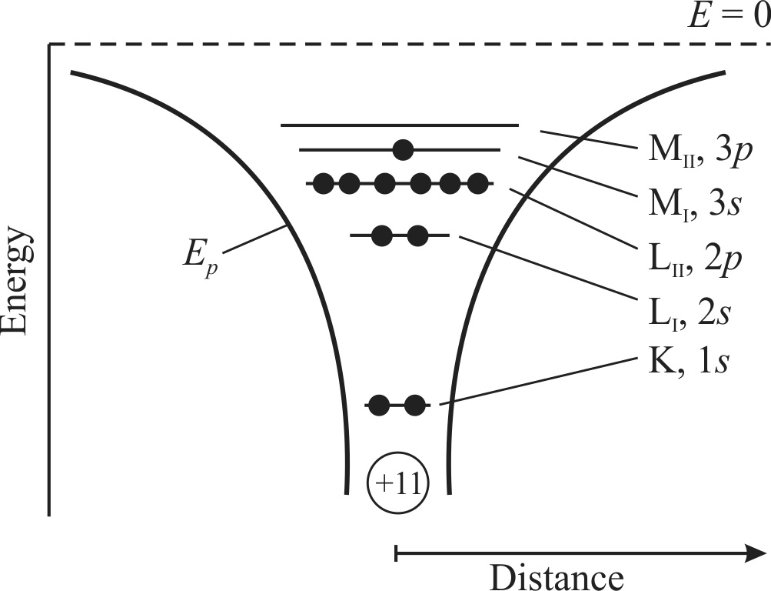

Fig. 3.19. Electronic arrangement in sodium atom: valence electron is located on the level 3s in
M₁ shell; K, L, M – designations of electronic shells, E_{p} – potential energy
Energy diagram of the sodium atom, that has 11 orbital electrons, which balance the same magnitude positive charge of a nucleus, is shown in Fig. 3.19. First two electrons occupy the lowest level of energy 1s in the K-shell. Next, third and fourth electrons occupy the lowest energy level 2s (shell L_{I}), the fifth electron is located in a lowest remaining level (shell L_{II}) and so on. From Fig. 3.19 one may conclude, that on the third level six electrons are set. However, this is actually a blending of three power levels that differ by a little energy (this is peculiar in atoms with low atomic number), so they can not be depicted with the boundaries.
With addition of each subsequent electron, a form of potential energy curve E_{p}, Fig. 3.19 changes, while the location of all energy levels becomes different, because a net charge of system changes. Correspondent energy levels for all 11 electrons are shown as a characteristic of an neutral atom of sodium. Each outer electron can approach to the atom with more low velocity, because it is subjected not only to attraction from nucleus, but to repulsion from other, more deep electronic shells.
At the highest level M_{I} (Fig. 3.19) non-excited single sodium atom has only one valence electron (in state 3s), and just this electron determines most of chemical, electrical and optical properties of sodium. The remaining 10 electrons are located so deep in the potential energy well, that they can not participate in conventional chemical, electrical or thermal processes.
In case of solid state formation from the individual atoms, it is possible to present an energy picture in a first approximation, constructing potential energy curves for series of atoms, located in a distance, equal to the crystal lattice constant, Fig. 3.20. Because atoms in a crystal lattice of solids are close to each other, the potential curve between them can not rise to E = 0, as it happens with the atom located out of crystal. The potential energy maximums between the atoms do not reach even the energy of a single valence electron in each atom. Therefore, nothing prevents the valence electrons, which originally belongs to an atom, to leave it and start move freely through the crystal under the influence of heat and other influences. At that, in any local volume of crystal it should not be more or less electrons, that corresponds to the electrical neutrality of a crystal body.

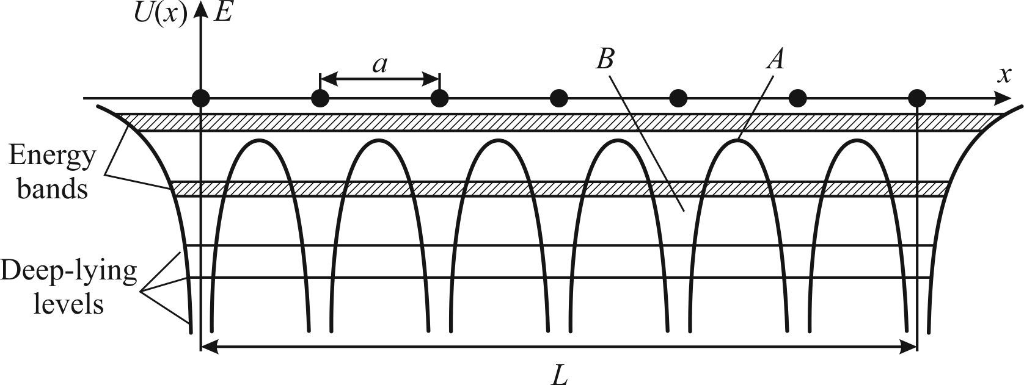

Fig. 3.20. One-dimensional energy model of crystal: a is interatomic distance; L is overall size of crystal; A is potential barrier that limits electrons transition from one atom to neighbour;
B is potential well

As it is shown in the simplified diagram in Fig. 3.20, the valence electrons belong whole crystal with the same energy. But it would be contrary to the Pauli principle. Moreover, experiments show that the emission spectra of solids are no longer discrete, as atomic spectra, but are continuous. The point is that discrete energy levels of atoms becomes split, and they form the zones, consisting of the same number of separate levels, as there are atoms in a crystalline body. It is expected, that a crystal is characterized by so many zones, as many energy levels has an isolated atom of same substance (see Fig. 3.17). In this example, in a cubic centimetre of sodium crystal a number of levels of electrons in zone equals 3⋅10²², at that, all valence electrons occupy different levels, but in the same area 3s.
As can be seen from Fig. 3.21, the valence band holds N close located energy levels and correspondingly to the Pauli principle, can accommodate 2N electrons. Therefore, the levels of a valence band are only half filled, since a separated sodium atom has only one valence electron on each level. In addition, specifically for sodium, the width of highly placed zones is such, that zones 3s and 3p overlap each other.
As a result, some electrons move out from the 3s zone to the lower levels of 3p zone, so both zones are filled together until the entire stock of electrons will be exhausted (other energy zones, located above the areas that overlaps, are not shown to simplify a figure). Thus, the valence band of a sodium crystal is not fully occupied by electrons. The top energy level, which in the metals is occupied by electrons at temperatures T = 0, is called a Fermi level, E_{F}.

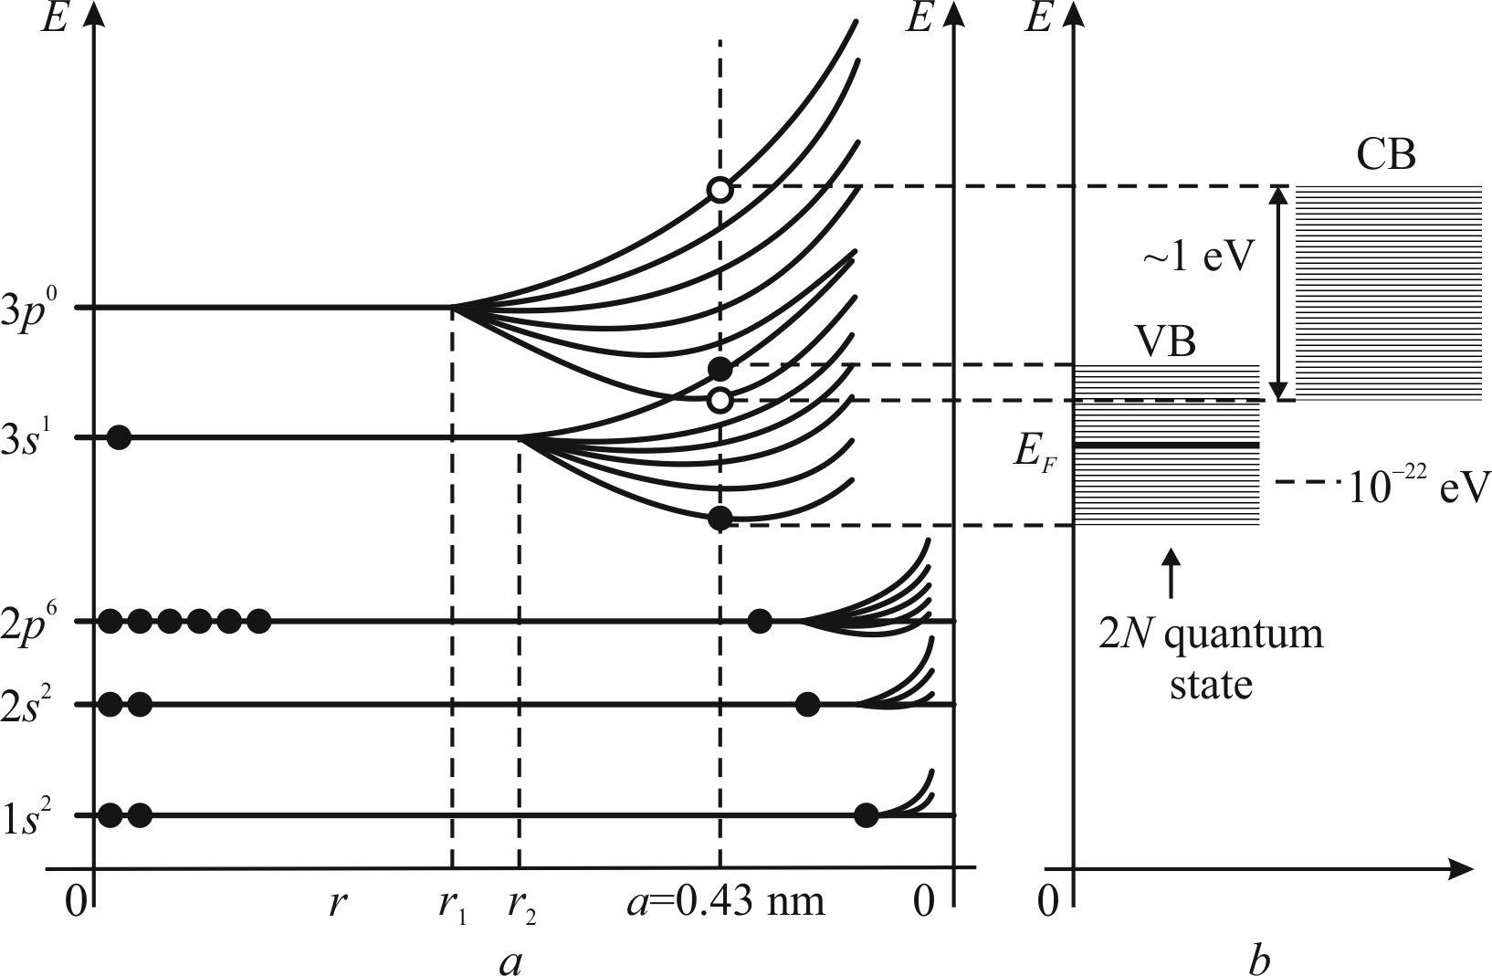
Fig. 3.21. Electronic energy spectra of system of N atoms of sodium (Na) depending on distance between them; CB – conduction band; VB – valence band, E_{F} – Fermi level
Valence electrons of metal are not located near the individual atoms, but move freely around the crystal, similar to gas molecules in a certain vessel. The system of electrons in crystals is called electronic gas (or electronic-liquid). A Fermi level takes to "electronic-liquid" in crystal the same role, as a fluid level in the communicating vessels. If two crystals with different Fermi levels are touched to each other, the electrons would "flow" from one crystal to another until the Fermi levels will be aligned. A clear definition of Fermi level position is given in the thermodynamics.
If the electrical field is applied to metallic crystal, the electrons can change their energy, going from one level to the other (located very close). These electrons are called free. They, in addition to the random thermal motion, moved in the opposite direction to the electrical field, which causes an appearance of electrical current. The alkaline (monovalent) metal sodium is the simplest case of electronic levels location in the energy spectrum. Sodium demonstrates a purely electronic conductivity (which is established experimentally by the Hall effect study and using a sign of thermo-electromotive effect.
More complicated is the electronic spectrum of a copper (which, however, is not so difficult, as the spectra of some rare earth metals). However, already in the case of copper, a contribution to conductivity is made not only by the free electrons, but also by the electronic vacancies – holes. Energy diagram of the copper crystal – a metallic rigid body – is shown in Fig. 3.22.

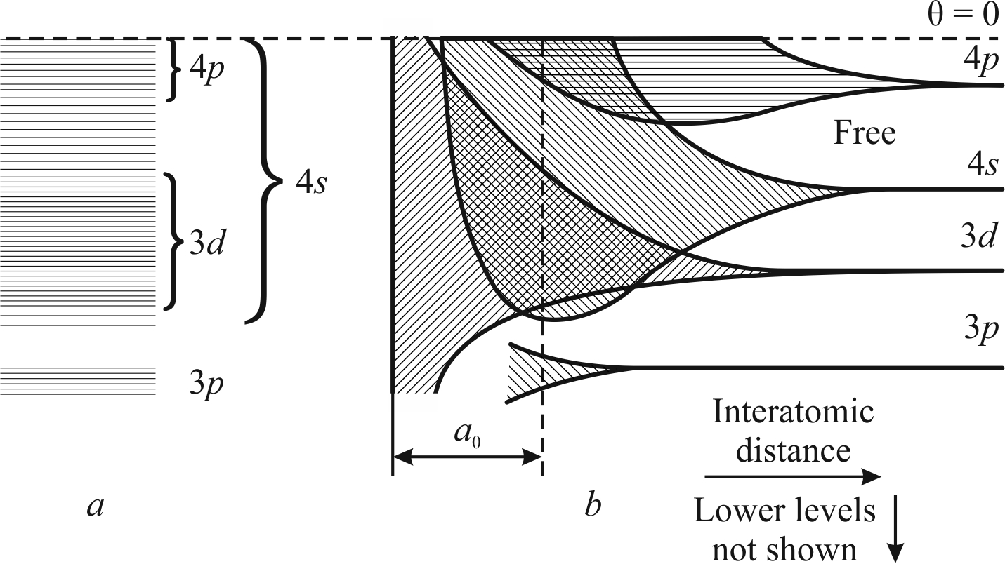
Fig. 3.22. Energy bands of copper overlap (a) and splitting of energy levels in the case of copper atoms convergence (b); а₀ – lattice constant (zones are arbitrary shading, lower levels not shown)
Not only overlapping energy band diagram in copper is shown, but also the formation of energy bands in the case of individual atoms convergence. Energy levels in Fig. 3.22, b looks discrete and narrow, as well as for individual atoms of copper. With an convergence of atoms, the interaction between electrons of the outer shells starts, and the overall energy levels are split, creating a zone. With subsequent convergence of atoms, the splitting amplifies, and energy levels become deeper.
When an interatomic distance of crystalline copper becomes equal to the lattice constant a₀, the zones 3d, 4s and 4р become such extended, that overlap each other, as it is shown in Fig. 3.20, a. Deeper energy bands (only 3p level is shown) expand considerably less. In the entirely separated copper atom, its energy levels are completely filled up to 3d. On the level 4s, which two electrons can contain, the only one valence electron in each atom is located. In the crystal of copper, respectively, three top areas are completed.
In the above considered cases, a valence band is found or being partially filled with electrons (Na), or characterized by the overlapping energy bands, and the formation of a broader zone of levels, which remains unfilled (Cu). In the metallic solids, which are characterized by above shown energy diagrams, the electrons are free, and these materials are good conductors of an electrical current.
The interaction of atoms significantly changes their energy spectrum. Highly placed discrete energy levels of isolated atoms change into the wide energy bands-zones, when atoms join together in a crystal. The potential energy dependence of the electron’s coordinates U(x, у, z) radically changes: it becomes periodic. Neighbouring atoms of a crystal change each other potential by such a way, that they turn into a periodical set of potential barriers and potential wells. The interaction between atoms changes the initial position of discrete quantum states, and splits them into the separate, closely located energy levels. Allowed band, in which valence electrons are located, is called a valence band. For sodium crystal this band is formed as a result of 3s-splitting.
Thus, with a crystal lattice formation, all peculiar for given type of atoms electronic levels (as filled by electrons, so unfilled) are displaced as a result of neighbouring atoms influence to each other. In consequence of a convergence, the atomic energy levels of individual atoms become separated in the bands of energy levels of electrons, as it was shown previously for non-metallic rigid bodies in Fig. 1.12 and 1.14 in the Section 1.2.

3.7. Summary
1. Crystal is an aggregate of regularly spaced and strongly interacting with each other particles. However, the vibrations and other excitations of these particles can extend through a crystal in a form of weakly interacting waves with wave vectors k_{j} and frequency ω_{j}(k_{j}). Each wave can be associated with oscillator with frequency ω_{j}(k_{j}).
2. To explain main characteristics of solids, one should imagine, that they contain some "hidden" states, that resemble the properties of different aggregate states of matter, namely, the gas of quasi-particles (atomic vibrations), the quantum fluid (electrons in metal) and even the electrons-holes plasma (in semiconductors).

3. Quasi-particle is a collective movement (disturbance) of many close-fitting particles of solids, such as local vibrations of atoms in a crystal lattice. Although many atoms are involved in the each excitation, this movement nonetheless has an atomic scale, as the average energy of each excitation (phonon) is about k_{В}Т.

4. In the quantum systems, the energy distribution is expressed as the function of energy, a degree of degeneration, and a number of particles in the system. For particles, whose number in any state is unlimited, a special case of quantum statistics – a distribution of Bose-Einstein – is valid (such particles are called bosons). If the particles are a subject to Pauli principle (that is, in a certain state, the only one particle can exist), a Fermi-Dirac distribution is used, and particles are called the fermions.

5. Photon is a typical example of bosons, i.e., an electromagnetic wave, that can extend both in vacuum and in dielectric. Photon, as well as an electron, shows a dualism, sometimes revealing properties of particles. Corpuscular property of the object is an impulse while the wave property is a wave vector. Both of them are related by de Broglie ratio: р = ħk, and this ratio can be read as inversely: ħk = р. The spin of a photon is the integer-valued: photon can have only two states of spin: +1 and –1. Two spin states of photon means, respectively, right and left circular polarization of an electromagnetic wave; this fact is very important for understanding of some electro-optical and magneto-optical effects in solids.

7. Phonon is a quantum-mechanical description of elementary vibrational movement in lattice, in which some atoms oscillate with a single frequency. The comparison "wave → quantum oscillator → phonon" is arranged by such a way, that an energy of the excited state of each quantum oscillator E_{п} is an integer quantity of ћω_{j}(k): E_{n} = nћω_{j}(n + ½), where n = 0, 1, 2, 3, … (here n is the number of a certain type of phonons with impulse p = ћk and energy Е = ћω_{j}). The average number of phonons with impulse p and energy E is determined by the Bose distribution, and it is proportional to [еxp(ћω/k_{В}Т) – 1]^{–1}. Thus, an ensemble of interconnected harmonic oscillators, which describe vibrations of atoms in the crystals, can be expressed by a set of so-called normal (not interconnected) oscillators, whose number equals to number of degrees of freedom of a system.

8. The model of phonons in many cases allows to consider any solid as a "vessel", containing in it a "phonon gas". Phonons, like conventional gas particles, can move from the "wall to wall", facing each other. The gas of phonons is a main heat reservoir of solids, however, it differs from a conventional gas: the number of phonons in solids is not constant (while in a normal gas the number of molecules in the vessel is invariable). The number of phonons is greater, the more intense is the thermal motion of the atoms, i.e., the higher is the temperature. At high temperatures a number of phonons increases in proportion to the temperature T, but in the range of low temperatures (closer to absolute zero) their number tend to zero in proportion T⁴ – fourth degree of temperature.

9. There are acoustical phonons and optical phonons. It is obvious, that phonons can not leave crystal, because they are only a motion of the atoms of a crystal. At low temperatures, when a quantum description of crystal properties is necessary, a number of thermally excited optical phonons is extremely small, because heat energy is not enough for optical phonons formation. That is why, just the acoustic phonons determine a heat capacity and a thermal conductivity.

10. Phonons differ from photons, firstly, by relatively low velocity: their velocity corresponds to the sound, that is in four orders less, then light velocity. Secondly, phonons differ from photons by a distinction among the types of waves. Namely, elastic waves (phonons) can have one of three types of polarization (L + 2T), while the light waves (photons) can have one of two types polarizations (2T).

11. In the space of impulses, at low temperatures (Т < θ_{D}), thermally excited phonons occupy small area near the centre of Brillouin zone. As temperature increases, a number of phonons increases as well; as the temperature becomes higher, the space of impulses gets more uniformly filled with phonons. In the range of low temperatures a main contribution to the vibrational energy of crystal is given by long acoustic waves. The energy of corresponding oscillators is small, so they are easily excited. On the contrary, the short acoustic waves and the optical waves at low temperature practically are not excited: to their stimulation in the temperature range T < θ_{D} there is no enough heat.

12. Magnon, or a spin wave, is a quasi-particle, that exists in the crystalline substances with orderly arrangement of spins: ferromagnetics, antiferromagnetics and ferrimagnetics. Magnon is elementary magnetic excitations in a crystal, in which spin of electrons has one of the opposite projection relatively to a ground state. This excitement can move in a crystal lattice from one place to another due to the exchange interaction, and it is characterized by quasi-impulse and energy. Magnons properties can be describes by Bose statistics. In crystals, which have many atoms in an unit cell, there are several magnon branches (named by analogy with the relevant branches of phonons).

13. Magnons interact with each other and with other quasi-particles. The existence of magnons is confirmed by the experiments with neutrons scattering, as well as from electrons and light scattering in a magnetic, during which the spin waves are excited. The model of magnons is used in the solid-state physics to explain not only magnetic properties, but also to explain some thermal and high-frequency properties of the magnetics. For example, the increased heat capacity (C_{v}) of a ferromagnetic crystal below the Curie temperature (including the C_{v} maximum in the Curie point) is due to the fact, that (in addition to the phonon contribution to heat capacity) a similar contribution is made by the magnons.

14. Free electrons in a space can have any energy: they have continuous energy spectrum. However, electrons in an isolated atom, according to quantum mechanics, have the certain discrete values of energy. According to the Bohr postulate, in an isolated atom, energy of electron can take only strictly discrete values (respectively, one can assume, that electron occupies one of the orbitals). In a few atoms, combined by chemical bonds (i.e., in a molecule), electronic orbitals split in an amount, proportional to the number of atoms, forming the so-called molecular orbitals. A similar discrete electronic spectrum is also a characteristic of the nanoparticles, holding in a dozen atoms.

15. In the macroscopic crystal – solid body with tightly bound atoms – the number of possible electronic orbitals becomes very large, so that an electronic energy spectrum consists of levels, joint in the allowed energy bands, which are separated by the forbidden energy bands. Since the difference in energies of electrons for adjacent orbitals is very small, energy levels are split up almost continuously, and make the discrete sets (energy bands). One of them is called as valence band: at temperature, close to 0 K, in dielectrics and semiconductors electrons occupy in it all energy states. In the metals, the highest allowed band is a conduction band, in which conduction electrons levels are located.

16. In the basis of a band theory there are a number of approximations: first, it is believed, that the solid is a perfectly periodic crystal; secondly, it is assumed, that an equilibrium position of crystal lattice is fixed (nuclei during fast motion of electrons are practically immobile – this is an adiabatic approximation); finally, many-electrons system is reduced to the one-electron (an impact on given electron from all others electrons is accounted by the averaged periodic field).

17. Band theory is a foundation of modern theory of solids. It allows to understand a nature and to explain the important properties of conductors, semiconductors and insulators. The value of the band gap E_{g} (energy gap between valence and conduction bands) is a key value in the band theory; it defines the electrical and optical properties of crystals.

18. In various crystals, as well as in different forms of a same crystal, the energy bands are different. With a relative position of these bands, the substances are divided into three groups:
• conductors – in which conduction band and valence band overlap, forming a zone that is called conduction band; thus, the electron can move freely between them, when received any acceptable low energy (in the case of potential difference applying to conductor, the electrons are free to move from a point with less potential to a point with a larger potential, creating an electrical current);
• dielectrics – where bands do not overlap, and a distance between them is more than 3 eV; to transfer an electron from the valence band into the conduction band, a considerable energy requires, so the dielectrics-insulators, practically, cannot conduct electricity;
• semiconductors – their bands do not overlap, but the distance between them is less than 3 eV; to transfer an electron from the valence band into the conduction band less energy is required. Than in the case of dielectric, so in chemically pure (own, unalloyed) semiconductors only a weak electrical current can pass.

19. In more general approach of a solid state theory creation, it turns out, that a prediction of physical effects by the band theory methods is much wider of initial approximations. For example, small fluctuations of atoms around their equilibrium positions, that can be described as phonons, might be introduced as a perturbation of electronic energy spectrum. However, a number of many-electrons physical phenomena, such as ferromagnetism, superconductivity, and others, where the role of the excitons benefits, can not be consistently reviewed as part of the band theory.

